
Lime Microsystems

Surrey Tech Centre
Occam Road
The Surrey Research Park
Guildford
Surrey GU2 7YG
United Kingdom

Tel: +44 (0) 1483 685 063
Fax: +44 (0) 1428 656 662
e-mail: enquiries@limemicro.com

LMS7002EVB Quick Start Manual

The information contained in this document is subject to change without prior notice. Lime Microsystems assumes no responsibility for its use, nor for infringement of patents or other rights of third parties. Lime Microsystems' standard terms and conditions apply at all times.

REVISION HISTORY

The following table shows the revision history of this document:

Date | Version | Description of Revisions
05/06/2014 | 2.0 | Initial version
2/07/2014 | 2.1 | Updated GUI pictures and new control descriptions
8/08/2014 | 2.2 | Updated GUI pictures and new control descriptions and 7.23 section added
23/10/2014 | 2.3 | Updated Figure 2
05/11/2014 | 2.4 | Updated GUI controls description. GUI version 3.6.3159.7344
03/04/2015 | 2.5 | Updated copyright notice and added licence info

Contents
Introduction 8
Development System Content 9
Overview of the Development Board 11
Installing the LMS7002M Control Software 13
1.1 Introduction to installing the software 13
1.2 Downloading the Software 14
1.3 Windows USB Setup 14
1.4 Determining Serial Port 17
1.5 Linux Setup 18
1.6 Starting Control LMS7002M Software 18
1.7 Connecting 18
Getting started with the EVB 20
1.8 Introduction to using the EVB7 20
1.9 Transmitter Setup and Basic Testing 21
1.9.1. SXT/SXR tab setup 21
1.9.2. TRF tab setup 22
1.9.3. TBB tab setup 22
1.10 Testing the TX Output 23
1.10.1. TX Basic Operation Checks 24
1.11 Receiver Setup and Basic Testing 25
1.11.1. SXT/SXR tab setup 25
1.11.2. RFE tab setup 26
1.11.3. RBB tab setup 27
1.12 Testing the RX Output 29
1.12.1. RX Basic Operation Checks 29
1.13 Testing With Minimal Equipment 30
EVB7 Connectors and Options 31
1.14 Introduction to the EVB7 Connectors and Options 31
1.15 Board Connections 31
1.15.1. FMC connector pin description 34
1.15.2. Digital I/O connector pin description 35
1.16 Hardware options 36
1.16.1. TCXO’s Configuration 37
1.16.2. EVB7 synchronization 37
1.16.3. SPI Control Configuration 38
1.16.4. Baseband Digital Interface Voltage 38
1.16.5. EVB7 Matching networks 39
Detailed Guide to LMS7002M Control Software 40
1.17 Control LMS7002M – Software Description 40
1.18 Control LMS7002M – Window Panels. 40
1.18.1. GUI Control panel 40
1.18.2. Configuration panel 40
1.18.3. Log panel 42
1.19 The Menu Bar 43
1.19.1. The File Menu 43
1.19.2. The Option Menu 43
1.19.3. The Tool Menu 43
1.19.4. The Help Menu 44
1.19.5. The Button Menu 44
1.19.6. The Configuring Channel Controls 44
1.20 Board Setup (Si5351C and ADF4002) 45
1.21 RFE 46
1.22 RBB 48
1.23 TRF 50
1.24 TBB 52
1.25 AFE 54
1.26 BIAS 55
1.27 LDO 56
1.28 XBUF 57
1.29 CLKGEN 58
1.30 SXT/SXR 61
1.31 Application Note on Tuning PLLs on LMS7002M 63
1.32 LimeLight & PAD 64
1.33 TxTSP 68
1.34 RxTSP 70
1.35 CDS 72
1.36 BIST 73
1.37 SPI 74
1.38 Introduction 77
1.39 Recommended Test Equipment 77
1.40 Agilent MXG Setup 78
1.40.1. Setting Common Mode Voltage 78
1.40.2. Enabling the Arbitrary Waveform Generator 79
1.40.3. Downloading *.wfm Files to the Signal Generator 80
82
NOTICE OF DISCLAMER 83

Table of Figures

Figure 1 Development System Content 9
Figure 2 Board block diagram 11
Figure 3 Device Manager content 14
Figure 4 Device properties 15
Figure 5 Update Driver Wizard. 15
Figure 6 Hardware wizard. Install driver manually 16
Figure 7 Check for new communication port 17
Figure 8 GUI communication settings. 18
Figure 9 GUI detected device and firmware version 19
Figure 10 Tx Test Setup 21
Figure 11 SXT register setup procedure 22
Figure 12 TBB register setup procedure 23
Figure 13 Basic TX testing using DC offset resulting in LO leakage 23
Figure 14 Basic TX testing using WCDMA modulation 24
Figure 15 Rx Test Setup 25
Figure 16 SXR register setup procedure 26
Figure 17 SXR register setup procedure 27
Figure 18 SXR register setup procedure 28
Figure 19 RX analog output on Spectrum Analyser. 29
Figure 20 Design kit connection descriptions, Top view. 31
Figure 21 Design connection descriptions, Bottom view. 32
Figure 22 GUI window diagram 41
Figure 23 GUI Control Panel window 41
Figure 24 GUI Configuration Board Setup window 42
Figure 25 GUI Log panel 42
Figure 26 GUI Message Log tab 43
Figure 27 GUI Register Map window 43
Figure 28 GUI Board Setup tab 45
Figure 29 GUI RFE tab 47
Figure 30 GUI RXBB tab 48
Figure 31 GUI TRF page 50
Figure 32 GUI TBB page 52
Figure 33 GUI AFE tab 54
Figure 34 GUI BIAS tab 55
Figure 35 GUI LDO Power downs & Bias & Noise filter tab 56
Figure 36 GUI LDO Voltages tab 57
Figure 37 GUI XBUF tab 57
Figure 38 GUI CLKGEN tab 58
Figure 39 GUI SXT/SXR tab 61
Figure 40 GUI Limelight&PAD Modes tab 64
Figure 41 GUI Limelight&PAD Sample position tab 66
Figure 42 GUI TxTSP tab 68
Figure 43 GUI RxTSP tab 70
Figure 44 GUI CDS tab 72
Figure 45 GUI BIST tab 73
Figure 46 GUI SPI tab 74
Figure 47 Agilent N5181A/82A MXG Front Panel 78
Figure 48 CMD window showing successful ping 81
Figure 49 CMD window with ftp connection 82
Figure 50 CMD window ftp file transfer 82

Introduction
The Lime Development System is a comprehensive hardware and software combination that allows users to evolve and refine a wireless sub-system. It can be combined with a baseband processor such as an FPGA or DSP processor to develop a comprehensive wireless solution.
The EVB7 module is a high-speed wireless communication module, based on the LMS7002M fully programmable RF transceiver. It is designed to support 2G, 3G, 4G/LTE radio systems with both time-division duplex (TDD) and frequency-division duplex (FDD) applications, M2M and software defined radios. The wireless communication module covers the frequency range of
100 kHz to 3.8 GHz, including licensed and unlicensed bands. The channel bandwidth is programmable from less than 100 kHz to 108 MHz through a combination of analog and digital filtering via the easy-to-use GUI software.
The EVB7 provides system designers with the ability to connect the board to any type of baseband, FPGA or CPU and allow them to implement their ideas for various wireless communication applications.
This document describes how to make a quick start with the LMS7002M using the EVB7 module. Section begins by listing the contents of the Quick Start kit. Section gives a general description of the evaluation board features. Section describes the procedure for obtaining and installing the LMS7002M control software “Control LMS7002M” for both Windows and Linux platforms. Section describes how to connect and use the EVB and LMS7002M control software “Control LMS7002M” for the Quick Start example configurations. Section describes in detail the EVB connectors and hardware options. Section describes in detail how to use the LMS7002M control software “Control LMS7002M”. Section 1.38 describes calibration procedures. Appendix 1 details the recommended test and measurement equipment, and how to set up the test equipment to work with EVB7 and the LMS7002M.

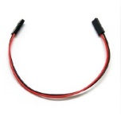
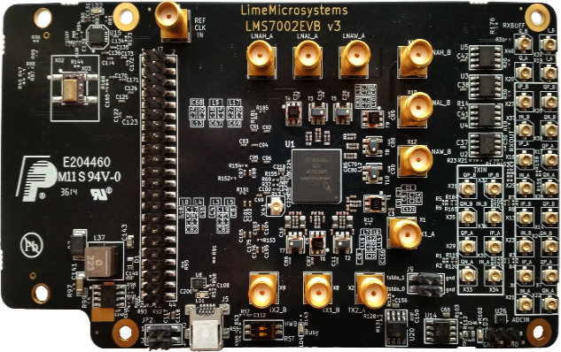
Development System Content

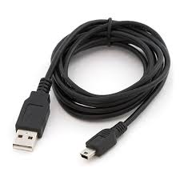

Figure 1 Development System Content

Complete development kit content consists of:
- Hardware
  - 1 – LMS7002EVB v3 board
  - 1 - Power supply cable that connects the EVB7 board to any lab power supply unit
  - 1 - USB-A to Micro-USB-B cable
  - USB stick with software
- Software:
  - LMS7002M GUI “Control_LMS7002M”
  - Windows drivers
- Documentation:
  - Quick Starter Manual
  - LMS7002M datasheet
  - Complete PCB database
  - Register map document
  - Generator waveforms

Overview of the Development Board

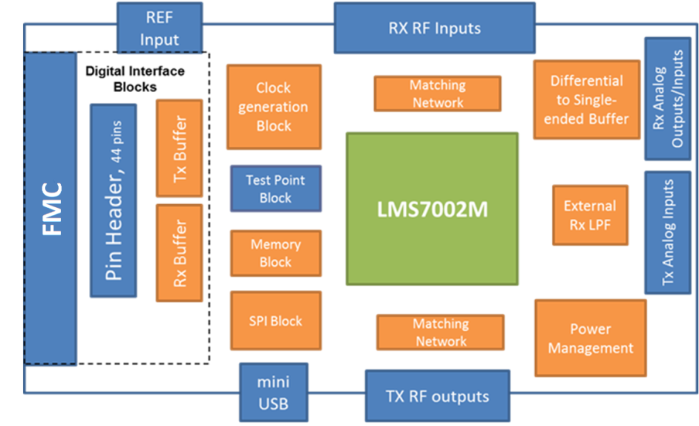

Figure 2 Board block diagram

A photograph of the development board is shown in Figure 1. A block diagram of the board is shown in Figure 2. The connections are shown in blue, the LMS7002M chip is shown in green, and the other parts are shown in orange. The core of the board is the LMS7002M transceiver chip, which has multiple RF, analogue and digital interfaces.

The evaluation board includes RF matching networks for the LMS7002M. These matching networks include wideband transformers to allow operation over the entire frequency range. However, the matching networks have been optimized for operation over selected frequency bands and offer the best performance in these bands. Connectors are provided for 4 RF transmitter outputs and 6 RF receiver inputs. Further details of the matching networks are provided in section 1.16.5.

The evaluation board includes connectors for the baseband analogue differential receiver outputs and differential transmitter inputs. Additionally, on board high speed differential to single ended converters allow the EVB7 receivers to indirectly drive 50R test equipment such as spectrum analysers for baseband testing.

The evaluation board includes a clock generation block, which by default, is a standalone
30.72 MHz low phase noise TXCO. TXCOs at other frequencies can also be fitted and three different footprints are supported. The EVB7 can be easily modified to operate with external clock sources. It can also be synchronized to the standard 10 MHz reference of measurement equipment via an on board PLL. Details of the required changes on EVB7 are given in section 1.16.1 and 1.16.2.

EVB7 includes two kinds of digital I/O, one for control only, and two for data and control.

The USB interface is used to control the LMS7002M SPI via the LMS7002M control software. The USB port is converted to SPI by an on board microcontroller.

The FMC connector or the 44 pin header can be used for the buffered digital interface and can be connected to compatible platforms such as the Lime “Stream” board. The Lime “Stream” board also provides connections to general purpose lab equipment such as pattern generators and logic analysers. A pin list for the digital interface can be found in section 1.15. The logic level for the digital interface can be set by modifying EVB7 and is described in section 1.16.4. Additionally these connectors can be used to control the SPI but require the board modifications described in 1.16.3.

A 7th order LC filter can be selected between the analogue output of the LMS7002M and its digital inputs by using the LMS7002M control software. This allows additional filtering at
100 kHz (IF BW) for 2G applications.

The board includes memory to work with the LMS7002M internal microcontroller. This is intended to provide calibration support for the LMS7002M and is currently under development. The memory is programmed via the LMS7002M control software and the USB/SPI interface.

Test points are provided for various test signals including the LMS7002M internal peak and RSSI detectors as well as various PLL test signals.

More detailed information on the connectors for the evaluation board can be found in section 1.14. Information about PCB options supported is in section 1.16.

Installing the LMS7002M Control Software

Introduction to installing the software

To operate the EVB7 board, the LMS7002M Control Software, “LMS7002M Control” has to be downloaded from http://www.limemicro.com and installed. The software consists of three parts.
- The main LMS7002M control Software, which provides a GUI to control the chip.
- The USB driver “USB to LMS7002M”, which provides an interface between the PC and the EVB7 SPI microcontroller.
- The EVB7 microcontroller firmware, which is preinstalled on the board prior to shipping.
Section 1.1 describes the how to download the software from the Lime Microsystems web page.

Sections 1.2, 1.3 and 1.4 describe the set up for the Windows Operating System. Section 1.2 describes the installing of the “USB to LMS7002M” driver. Section 1.3 describes the Windows OS set up. Section 1.4 describes how to identify which USB port is being used.

Section 1.5 describes installing the USB driver in a typical Linux distribution. Section 1.6 describes how to start the “LMS7002M Control Software”.

Section 1.7 describes how to connect the EVB7 with the “LMS7002M Control Software” via the USB interface.

A simple demonstration of the “LMS7002M Control Software” is given in section . A detailed description of the “LMS7002M Control Software” is given in section .

Downloading the Software

To get started with the EVB7 board control software, download the latest version from www.limemicro.com.

Windows USB Setup

The steps to setup “Control LMS7002M” software are as follows (please note that these steps may vary based on the specific version of Windows software being used and you may need to be logged in as Administrator to accomplish them):

- Connect EVB7 board to your PC via the USB cable.

- Go to Control Panel > System > Device Manager

- Locate USB to LMS7002M under Other devices and press right click to select Properties (Figure 3)

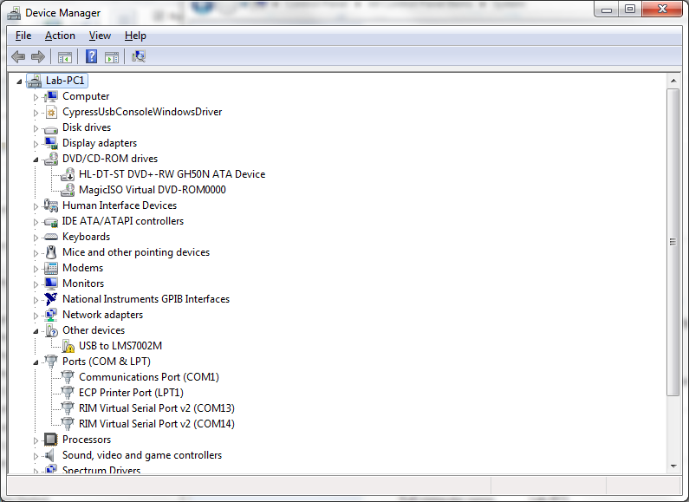

Figure 3 Device Manager content

- When a new window pops-up press Update driver (Figure 4)

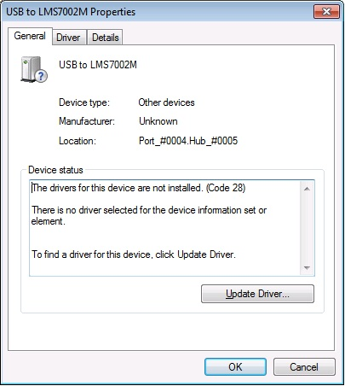

Figure 4 Device properties

- Select Browse my computer for driver software, locate the driver provided with EVB7 board and press Next (Figure 5)
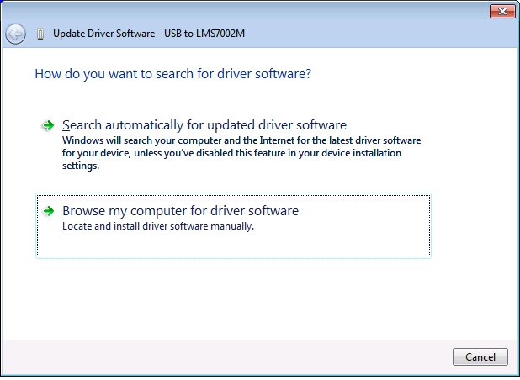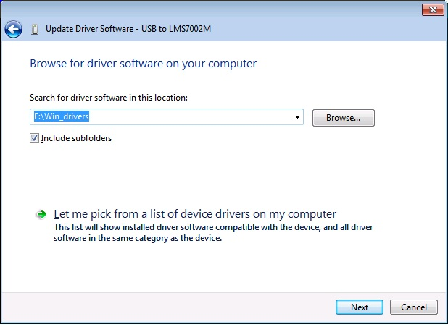

Figure 5 Update Driver Wizard.

- If the Windows Security window appears, select Install this driver software anyway (Figure 6)

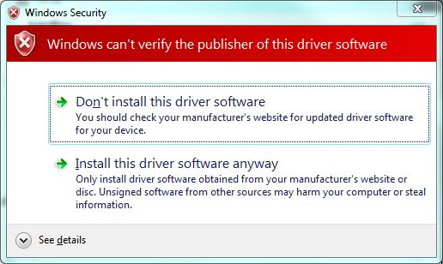

Figure 6 Hardware wizard. Install driver manually

Windows should proceed to install drivers at this stage. Generally, once the above steps have been taken for the EVB7, these steps do not need to be repeated.

IMPORTANT:
Before running the control software, unplug then plug your device back into your computer.

Determining Serial Port

After driver installation, Windows will assign to your EVB7 board a serial port. To check your board serial port number, please follow these steps:

- Go to Control Panel > System > Device Manager

- Locate USB Virtual Serial Port under Ports (COM & LPT)

Note that in this system example it has enumerated as COM2 (Figure 7).

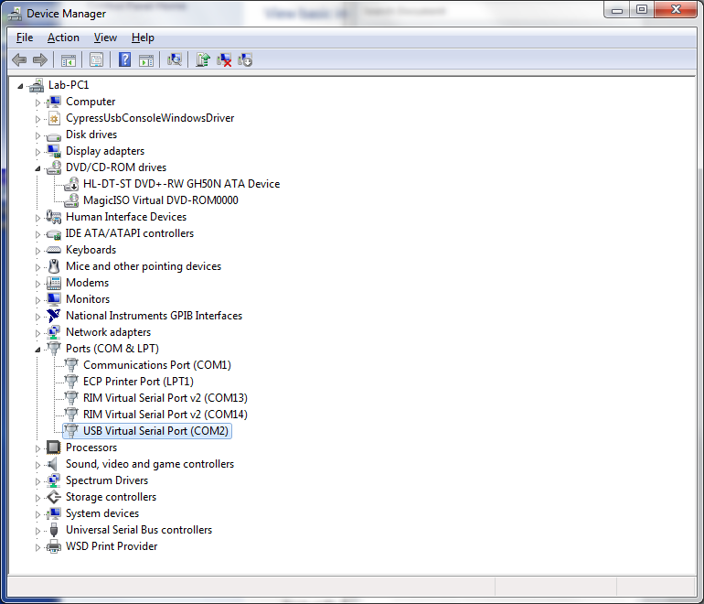

Figure 7 Check for new communication port

Linux Setup

For Linux users, there is no need to install USB drivers, as the system will assign drivers automatically once the EVB7 board is connected to PC.

To determine port number the easiest is via the command line and type command:

$ setserial -g /dev/ttyS[0123]

Starting Control LMS7002M Software

Apply +5V to the board and start “Control LMS7002M” software. The application must be run under administrator privileges. To do that, right click on the “Control LMS7002M” icon and select Run as an Administrator. This will provide administrator privileges, which are required for EVB7 board communication via USB.

Connecting

Once the Windows driver is installed and the control software has been lunched, click on Options>Connection Settings. The Connection Setting windows will pop-up (Figure 8).

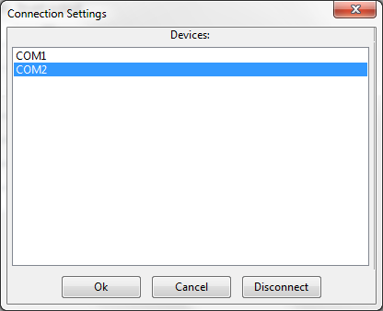

Figure 8 GUI communication settings.

Select the dedicated USB port number of the EVB board. In this case, it is COM2, and press OK.

The GUI device name and firmware version will appear in the bottom (Figure 9), once connection with the board is established.

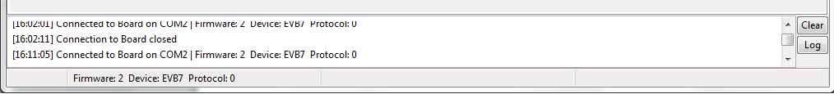

Figure 9 GUI detected device and firmware version

Getting started with the EVB

Introduction to using the EVB7

The EVB7 allows powerful demonstrations of the LMS7002M transceiver. In this quick start guide, we demonstrate the board operating with analogue inputs and outputs. A future version is planned to demonstrate the board operating with digital inputs and outputs and the Lime “Speed” board.

Section 1.9 describes the set up of the transmitter, with section 1.9.1 describing how to set up the SXT (TX PLL) and section 1.9.2 describing how to set up the TX analogue baseband and RF tabs of the LMS7002M Control software. Section 1.11 describes the set up of the transceiver for basic tests, with section 1.11.1 describing how to set up the SXR (RX PLL) and section 1.11.2 and 1.11.3 describing how to set up the RX analogue baseband and RF tabs of the LMS7002M Control software.

The analogue quick start demonstration assumes the user has all the equipment listed in Appendix 1.39. Users with less equipment can use the set up of Section 1.13.

Transmitter Setup and Basic Testing

To test the Tx path, the Agilent generator is used as an external baseband source. This is connected to the Tx path via the analog inputs and generates a WCDMA modulation signal at socket X1 (TX1_A) as shown in Figure 10. To generator settings are described in section 1.40 (Appendix A).

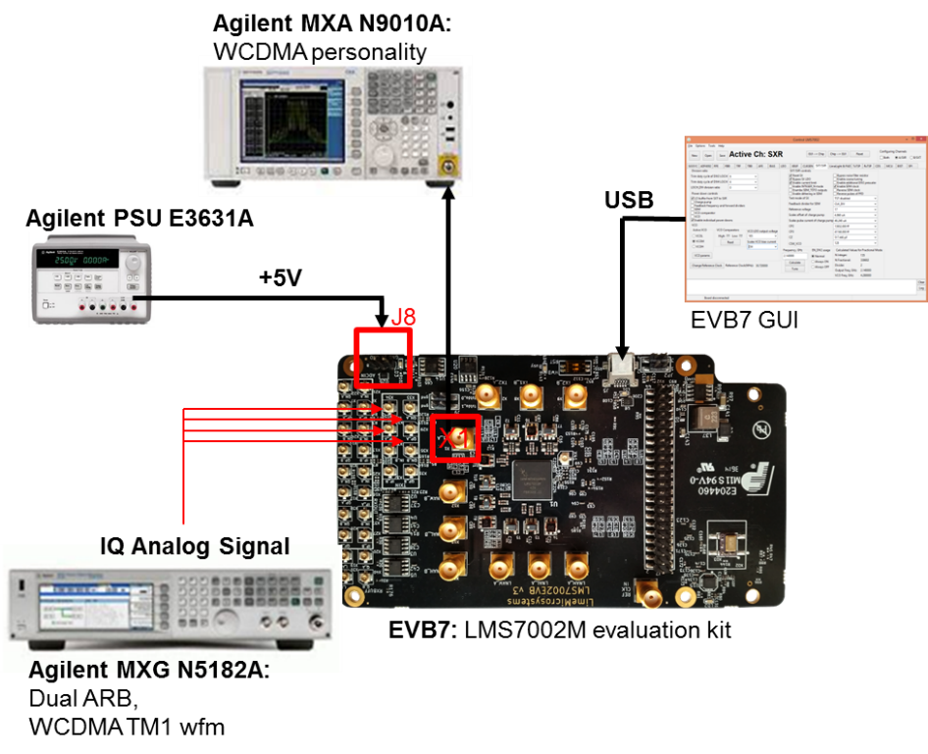

Figure 10 Tx Test Setup

SXT/SXR tab setup

After power up, connect the GUI to the board and select the SXT/SXR tab. To configure the Tx LO to 2140 MHz, do the following:

- Select the B/SXT in the configuration channels window to control TxPLL
- Enable Tx PLL VCO (Deselect).
- Type the wanted frequency in Frequency, GHz box. In this case, 2140 MHz.
- Press Calculate followed by Tune.

See Figure 11 below to check selections.

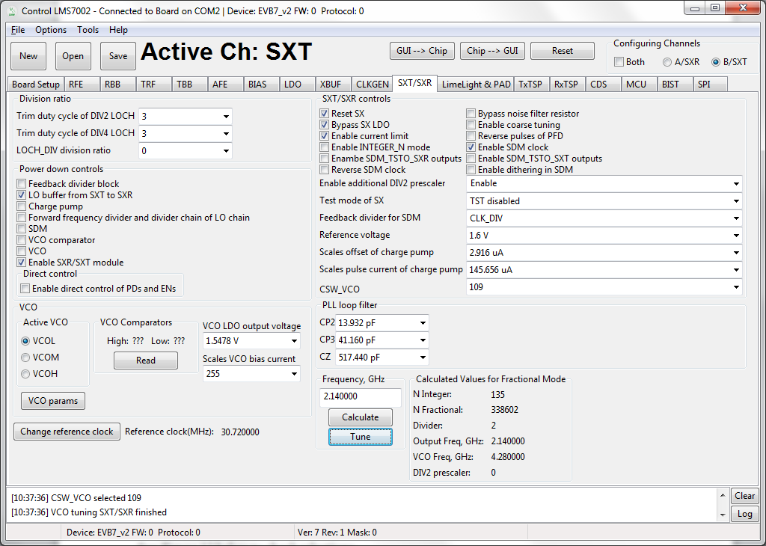
Step 1

Step 2

Step 3

Step 4

Figure 11 SXT register setup procedure

TRF tab setup

The TRF tab controls the TX RF gain and output path. By default the Tx RF gain is set to maximum ( TXPAD gain control set to ‘0’) and TXFE output selection set to Band 1 ( to X1 on EVB7 board) as the output path. For this test, we are not going to change these settings.

TBB tab setup

In the TBB tab the baseband gain and filter bandwidth are controlled. Follow the instructions below set up TBB:

- Select the A/SXR to control channel A.
- Enabled Tx IQ analog input path to current amplifier.
- Set Frontend gain to your wanted.
- Configure the base band filter settings. By default, high band filter (LPFH_TBB) is power on.

See Figure 12 below to check selections.

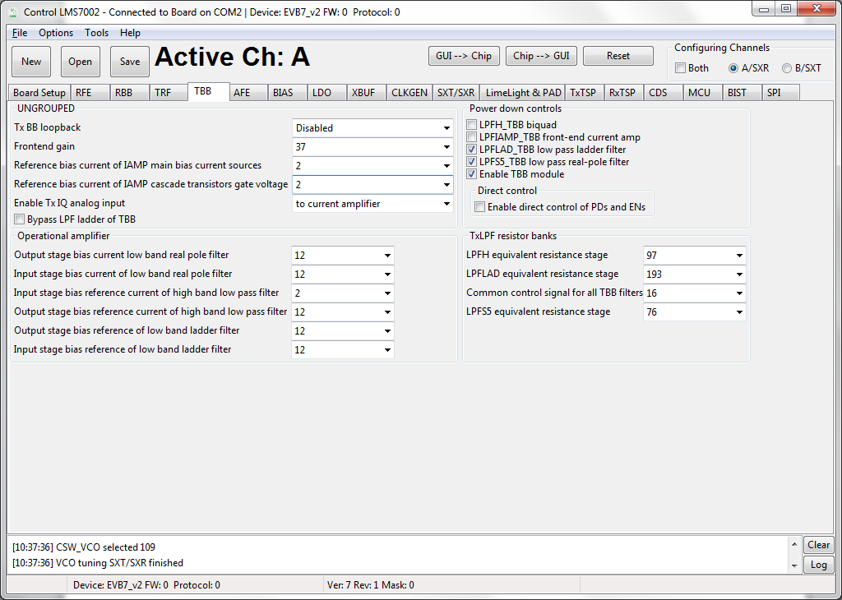
Step 1

Step 4

Step 2
Step 3

Figure 12 TBB register setup procedure

Note: the register preset file for Tx test ‘TX_2140_MHz_demo_setup.ini’ is supplied with design kit. You can load it by clicking menu button Open>> locate and select the file in ../LMS7GUI folder/ ‘TX_2140_MHz_demo_setup.ini’ >> select Open, followed by GUI--> Chip button. The select SXT/SXR tab and retune synthesizer.

Testing the TX Output

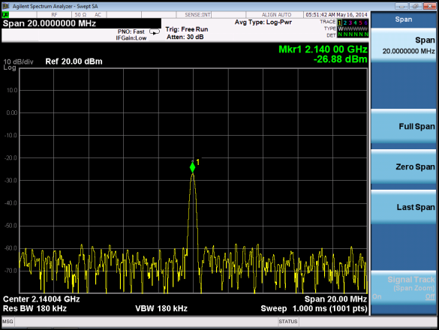
When the transmitter is configured as shown in section 1.9, the TX1_A output (socket X1) can be connected to a spectrum analyzer (SA). With the SA you can now observe the results of this basic operational test (Figure 13). The test is looking at the DC offset from the un-programmed data DAC as LO leakage and the example shown below is measuring a value of -26.8dBm.
Figure 13 Basic TX testing using DC offset resulting in LO leakage

When the baseband is enabled, the WCDMA modulation can be tested and the results of Figure 14 can be obtained with the MXG Spectrum Analyser.

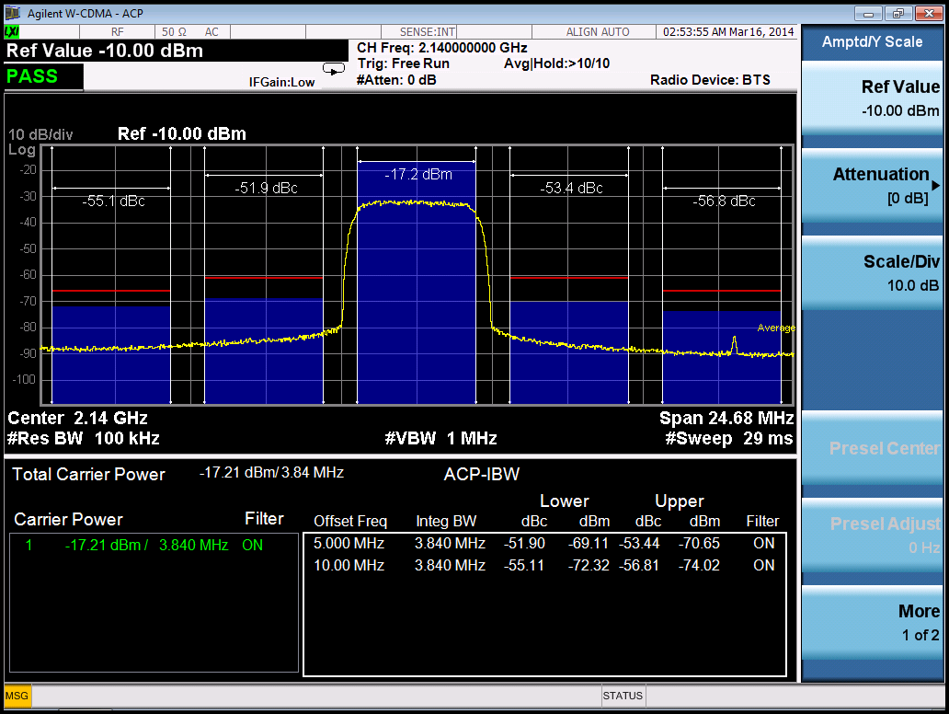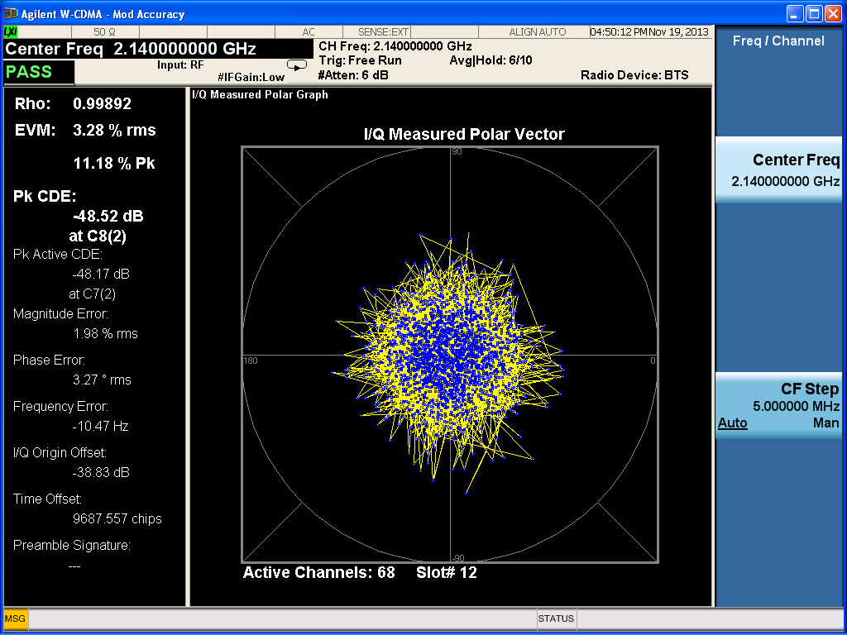

Figure 14 Basic TX testing using WCDMA modulation

TX Basic Operation Checks

To check the basic TX frequency and gain control, conduct some tests changing frequencies and gain settings. The following four tests are recommended:

TRF – TXPAD gain change setting from 0 to 31 and observe results. LO should vary by approx. 1 dB steps, 31dB range.
Change frequency from 2.14 GHz to 2.11 GHz and press ‘Calculate’/’Tune’ (CAP value should change), check the Spectrum Analyzer.
Change frequency from 2.11 GHz to 2.17 GHz and press ‘Calculate’/’Tune’ (CAP value should change), check the Spectrum Analyzer.

Receiver Setup and Basic Testing

The test bench for the receiver is shown in Figure 15. Basic functionality checks on the receiver side are achieved by using the Analog output from connector X20.

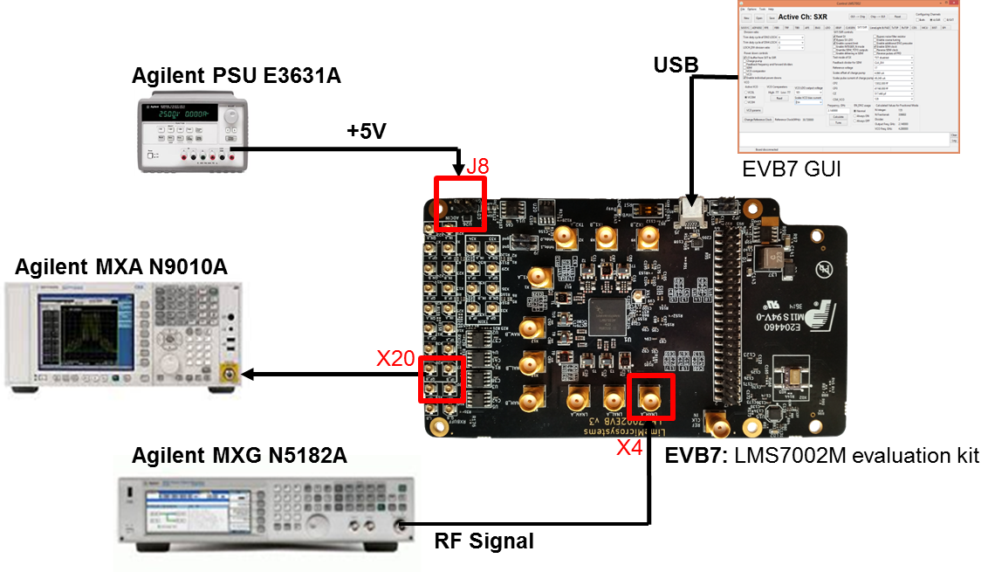

Figure 15 Rx Test Setup

SXT/SXR tab setup

Select the SXT/SXR tab. To configure the Rx LO to 1950 MHz, do the following:

- Select the A/SXR in the configuration channels window to control RxPLL
- Enable Rx PLL VCO (Deselect).
- Type the wanted frequency in Frequency, GHz box. In this case, 1950 MHz.
- Press Calculate followed by Tune.

See Figure 16 below to check selections.

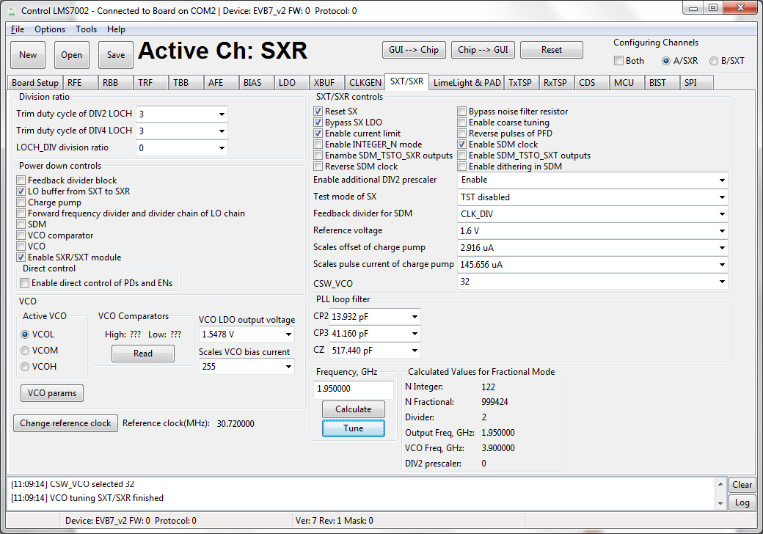
Step 1

Step 2

Step 3

Step 4

Figure 16 SXR register setup procedure

RFE tab setup

Select the RFE tab to configure the receiver RF front–end. Follow the configuration steps below:

- Enable LNA_RFE, RXFE mixer LO buffer and RFFE Quadrature LO generator.
- Select Active path to the RXFE. Select LNAH for this test. By default the is preselected.
- The LNA and TIA gain are preset to maximum.

See Figure 17 below to check selections.

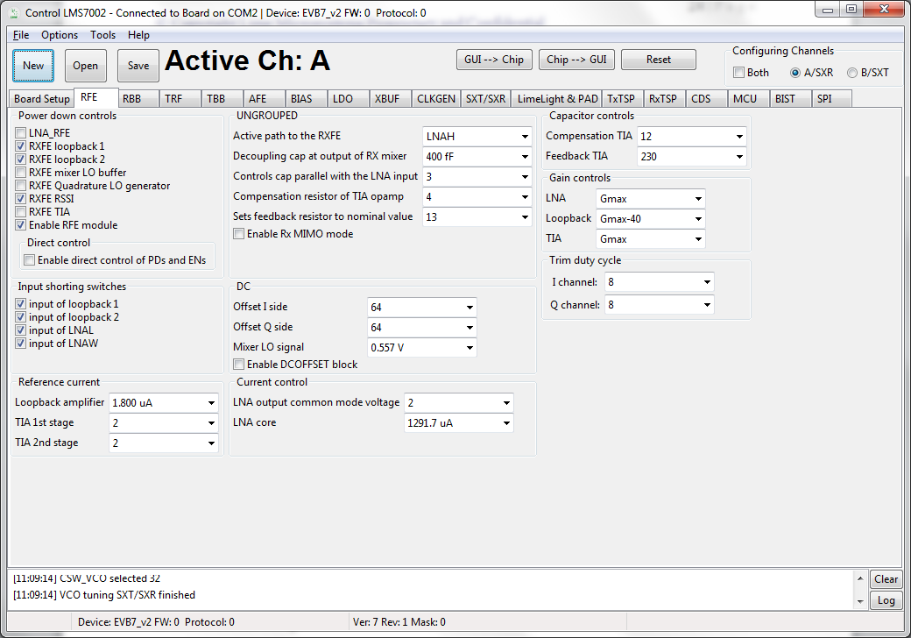
Step 1

Step 2

Step 3

Figure 17 SXR register setup procedure

RBB tab setup

Select the TBB tab to configure the PGA gain and baseband filter bandwidths. Follow the configuration steps below:

- Select PGA output to output pads. This selection enables receiver analog outputs.
- Set PGA gain to 19 dB.
- Configure filter bandwidth. By default the LPFL is selected.

See Figure 18 below to check selections.

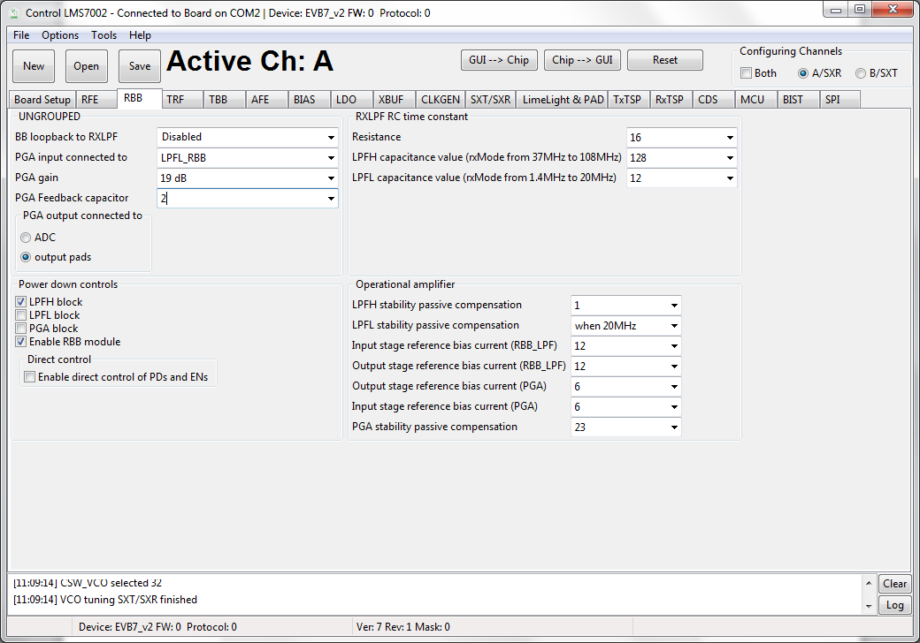
Step 1

Step 3

Step 2

Figure 18 SXR register setup procedure

Note: the register preset file for Rx test ‘RX_1950MHz_demo_setup.ini’ is supplied with design kit. You can load it by clicking menu button Open>> locate and select the file in ../LMS7GUI folder/ ‘RX_1950MHz_demo_setup.ini’ >> select Open, followed by GUI--> Chip button. The select SXT/SXR tab and retune synthesizer.

Testing the RX Output

Set the signal generator to 1955 MHz (i.e. 5 MHz offset from PLL frequency selected) and input a sine wave at -70 dBm into the evaluation board antenna connector (LNAH_A, connector X4).
Configure the receiver as showed in section 1.10. Connect an Analyser to X20 or X19. If everything is correctly setup, you should see the 1 MHz peak. See Figure 19 below.

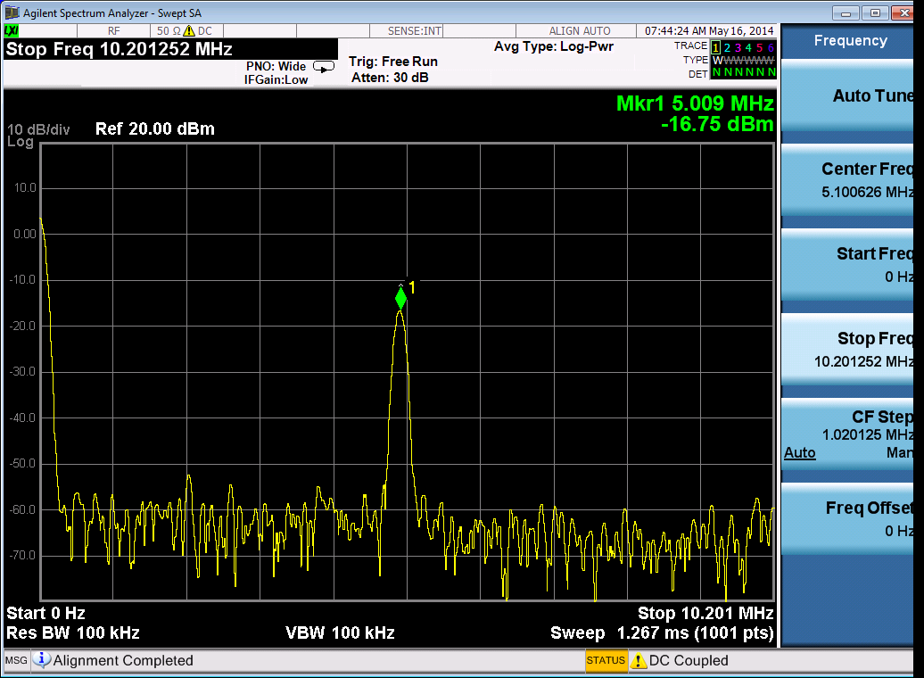

Figure 19 RX analog output on Spectrum Analyser.

RX Basic Operation Checks

To check the basic Rx frequency and gain control, conduct some tests changing frequencies and gain settings. The following six tests are recommended:

- RBB – change PGA gain setting from 19 to -12, observe results, gain should decrease.
- RFE – change TIA gain settings from Gmax to Gmin, observe results, gain should decrease.
- RFE – LNA gain change from Gmax to Gmax -30, observe results, gain should decrease.
- Change frequency from 1.95 GHz to 1.92 GHz and press ‘Calculate’/’Tune’. Change Signal Generator to 1.925 GHz (1MHz offset from PLL). Observe results.
- Change frequency from 1.92 GHz to 1.98 GHz and press ‘Calculate’/’Tune’. Change Signal Generator to 1.985 GHz (1MHz offset from PLL). Observe results.

Testing With Minimal Equipment

For users without all the equipment specified in section 1.39 (Appendix A) it is possible to link the TX1_A output (X1) to the receiver input LNAH_A input (X4) and rely on the LO leakage to provide an input signal to the RX.

Using the methods of section 1.9 and section 1.11 set the SXT to 2140 MHz and SXR to
2145 MHz and measure a 5 MHz signal with an oscilloscope to observe the RXI output at X19. The magnitude of the output signal can be controlled with the various gain controls in the RFE and TRF.

EVB7 Connectors and Options

Introduction to the EVB7 Connectors and Options

Section 1.15 describes the various connectors available on the EVB7. Section 1.16 describes the hardware options available on the EVB7, including reference clocks and the SPI control. The top and bottom of the board are shown in Figure 20 and Figure 21 respectively.

Board Connections

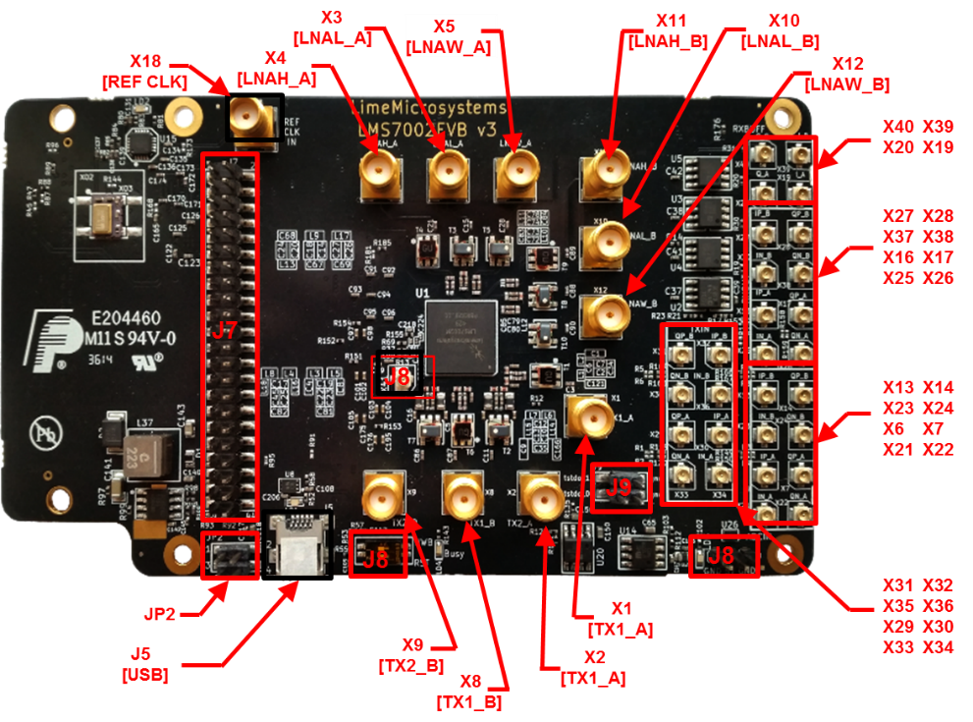

Figure 20 Design kit connection descriptions, Top view.
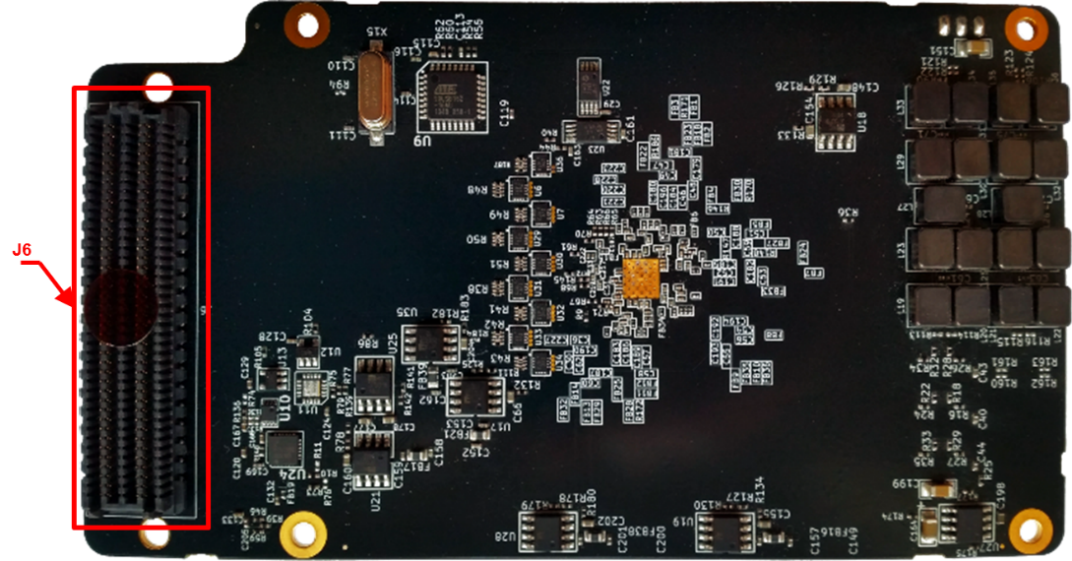

Figure 21 Design connection descriptions, Bottom view.

Table 1 describes the high level pin assignment for each connector on the design kit.

Table 1 Design kit connectors and switches
Connector | Schematic name | Description
J1 | +3.3V Voltage Supply Jumper | This jumper is used to supply +3.3 V from the EVB to the FMC connector connected boards
JP2 | BB supply | This jumper enables the supply to the EVB7 board from an FPGA development kit. U16 is a voltage regulator that converts +12 V to +5 V
J5 | USB | USB Connector to PC
J6 | FMC | The FMC (HPC) is a standard connector used to interface the Lime board directly to an FPGA design kit. The signal pin description is shown in 1.15.1 section.
J7 | Digital I/O Connector | This connector provides access to externally buffered, LMS70002M digital interface and SPI interface. Signal pin description showed in 1.15.2 section.
J8 | +5V Power Supply | +5 V supply connector
J9 | ATP | Analog Test Point
X1 | TX1_A | Transmitter TX1 output, channel A. Wideband transmitter output
X2 | TX2_A | Transmitter TX2 output, channel A. Lower bands transmitter output
X3 | LNAL_A | Receiver LNA_L input, channel A. Lower bands receiver input
X4 | LNAH_A | Receiver LNA_H input, channel A. Higher bands receiver input
X5 | LNAW_A | Receiver LNA_W input, channel A. Wideband receiver input
X8 | TX1_B | Transmitter TX1 output, channel B. Wideband transmitter output
X9 | TX2_B | Transmitter TX2 output, channel B. Lower bands transmitter output
X10 | LNAL_B | Receiver LNA_L input, channel B. Lower bands receiver input
X11 | LNAH_B | Receiver LNA_H input, channel B. Higher bands receiver input
X12 | LNAW_B | Receiver LNA_W input, channel B. Wideband receiver input
X18 | CLK I/O | Reference clock input used to synchronize test equipment with EVB7 board to calibrate frequency error. A 10 MHz reference from the test equipment connects to X18 connector
X19, X20, X39, X40 | RXBUFFI/Q | Receiver analog single-ended outputs
X16, X17, X25-X28,  X37, X38 | RXOUTI/Q | Receiver analog differential outputs
X6, X7,  X21-X23,  X13, X14 | ADCINI/Q | Receiver analog differential inputs
X29-X36 | TXINI/Q | Transmitter analog differential inputs
SW1 | U1 Reset | Switch to reset AT90USB162-16U and load new software. By default set to off

FMC connector pin description

The digital baseband interface can be established via the FMC connector J6. The signal pin description is shown in Table 2.

Note: FMC HPC connector has 400 pins, but not all pins are used. Some pins are not connected and some are connected to GND. Please refer to EVB7 schematic for more details.

Table 2 FMC connector signal pin description
Pin number | Schematic name | Function
D8 | SyntCLK1 | Clock Out, CMOS
D9 | SyntCLK2 | Clock Out, CMOS
H7 | IQSEL2_DIR | IQSEL direction control for port 2. If ‘1’ – input, ‘0’ – output
H8 | DIO_DIR_CTRL1 | Data direction control for port 2. If ‘1’ – input, ‘0’ – output
G9 | SDIO | Serial port data in/out, CMOS
G10 | DIG_RST
H10 | INTR | I2C port interrupt line, CMOS
H11 | SCLK | Serial port clock, positive edge sensitive, CMOS
H13 | RXFCLK | Clock from BBIC to RFIC during JESD207 mode, Port 2
H14 | RXEN | RX hard power off
G12 | RXMCLK | Clock from RFIC to BBIC during JESD207 mode, Port 2
G13 | RXIQSEL | IQ flag in RXTXIQ mode enable flag in JESD207 mode, Port 2
D14 | RESET | Hardware reset, active low, CMOS
D15 | IQSEL1_DIR | IQSEL direction control for port 1. If ‘1’ – input, ‘0’ – output.
C14 | SDO | Serial port data out, CMOS
C15 | DIO_DIR_CTRL2 | Data direction control for port 1. If ‘1’ – input, ‘0’ – output.
H16 | RXD11 | DIQ bus, bit 11, Port 2
H17 | RXD8 | DIQ bus, bit 8, Port 2
G15 | TXNRX1 | LimeLight protocol control
G16 | RXD10 | DIQ bus, bit 10, Port 2
D17 | SAEN | Serial port A enable, active low, CMOS
H19 | RXD7 | DIQ bus, bit 7, Port 2
H20 | RXD4 | DIQ bus, bit 4, Port 2
G18 | RXD9 | DIQ bus, bit 9, Port 2
G19 | RXD6 | DIQ bus, bit 6, Port 2
H22 | RXD3 | DIQ bus, bit 3, Port 2
H23 | RXD2 | DIQ bus, bit 2, Port 2
G21 | TXNRX2 | LimeLight protocol control
G22 | RXD5 | DIQ bus, bit 5, Port 2
H25 | TXMCLK | Clock from RFIC to BBIC during JESD207 mode, Port 1
H26 | TXIQSEL | IQ flag in RXTXIQ mode enable flag in JESD207 mode, Port 1
G24 | RXD0 | DIQ bus, bit 0, Port 2
G25 | RXD1 | DIQ bus, bit 1, Port 2
D24 | SBEN | Serial port B enable, active low, CMOS
H28 | TXFCLK | Clock from BBIC to RFIC during JESD207 mode, Port 1
H29 | TXD10 | DIQ bus, bit 10, Port 1
G27 | TXEN | TX hard power off
G28 | TXD11 | DIQ bus, bit 11, Port 1
H31 | TXD8 | DIQ bus, bit 8, Port 1
H32 | TXD6 | DIQ bus, bit 6, Port 1
G30 | TXD9 | DIQ bus, bit 9, Port 1
G31 | TXD7 | DIQ bus, bit 7, Port 1
H35 | TXD4 | DIQ bus, bit 4, Port 1
G33 | TXD5 | DIQ bus, bit 5, Port 1
H37 | TXD2 | DIQ bus, bit 2, Port 1
H38 | TXD0 | DIQ bus, bit 0, Port 1
G36 | TXD3 | DIQ bus, bit 3, Port 1
G37 | TXD1 | DIQ bus, bit 1, Port 1
F10 | G_PWR_DWN
F11 | DIO_BUFF_OE | DIO port buffer enable/disable. If ‘1’ – disable, ‘0’ – enable.
C31 | SDA | I2C port data line, CMOS
C30 | SCL | I2C port clock line, CMOS
D12 | RSSI_ADC0 | Analog test point
C10 | RSSI_ADC1 | Analog test point

Digital I/O connector pin description

The DIO card can be connected to EVB 7 via Digitail I/O connector J7. Connectr has 44 pins. The pin description showed in the Table 3.

Table 3 Digital I/O connector pin description
Pin number | Schematic name | Function
1 | TXD0 | DIQ bus, bit 0, Port 1
2 | TXD1 | DIQ bus, bit 1, Port 1
3 | TXD2 | DIQ bus, bit 2, Port 1
4 | TXD3 | DIQ bus, bit 3, Port 1
5 | TXD4 | DIQ bus, bit 4, Port 1
6 | TXD5 | DIQ bus, bit 5, Port 1
7 | TXD6 | DIQ bus, bit 6, Port 1
8 | TXD7 | DIQ bus, bit 7, Port 1
9 | TXD8 | DIQ bus, bit 8, Port 1
10 | TXD9 | DIQ bus, bit 9, Port 1
11 | TXD10 | DIQ bus, bit 10, Port 1
12 | TXD11 | DIQ bus, bit 11, Port 1
13 | TXFCLK | Clock from BBIC to RFIC during JESD207 mode, Port 1
14 | SyntCLK2 | Clock Out, CMOS.
15 | VDIO | +3.3V supply
16 | TXIQSEL | IQ flag in RXTXIQ mode enable flag in JESD207 mode, Port 1
17 | TXMCLK | Clock from RFIC to BBIC during JESD207 mode, Port 1
18 | TXEN | TX hard power off
19 | GND | GND
20 | GND | GND
21 | RXD0 | DIQ bus, bit 0, Port 2
22 | RXD1 | DIQ bus, bit 1, Port 2
23 | RXD2 | DIQ bus, bit 2, Port 2
24 | RXD3 | DIQ bus, bit 3, Port 2
25 | RXD4 | DIQ bus, bit 4, Port 2
26 | RXD5 | DIQ bus, bit 5, Port 2
27 | RXD6 | DIQ bus, bit 6, Port 2
28 | RXD7 | DIQ bus, bit 7, Port 2
29 | RXD8 | DIQ bus, bit 8, Port 2
30 | RXD9 | DIQ bus, bit 9, Port 2
31 | RXD10 | DIQ bus, bit 10, Port 2
32 | RXD11 | DIQ bus, bit 11, Port 2
33 | TXNRX1 | LimeLight protocol control
34 | SynCLK1 | Clock Out, CMOS
35 | RXFCLK | Clock from BBIC to RFIC during JESD207 mode, Port 2
36 | RXIQSEL | IQ flag in RXTXIQ mode enable flag in JESD207 mode, Port 2
37 | RXMCLK | Clock from RFIC to BBIC during JESD207 mode, Port 2
38 | RXEN | RX hard power off
39 | TXNRX2 | LimeLight protocol control
40 | SAEN | Serial port A enable, active low, CMOS
41 | SCLK | Serial port clock, positive edge sensitive, CMOS
42 | SDIO | Serial port data in/out, CMOS
43 | SDO | Serial port data out, CMOS
44 | RESET | Hardware reset, active low, CMOS

Hardware options

This section describes the configuration options and set up procedures for:

- TCXO’s and data clocks distribution
- EVB7 Synchronization
- SPI connection options

The board is shipped with the default mode which means a basic operation using an external digital I/O source via the FMC connector. Various configurations are available depending on the system requirements for development work. The configurations are summarized and the following sections describe the board modifications required to achieve these configurations.

TCXO’s Configuration

The LMS7002M device provides a flexible clocking scheme which allows the PLL reference clock and digital interface clock to be independently clocked. In addition, the digital interface clock can be generated internally in LMS7002M.

The EVB7 board is shipped with a 30.72MHz TCXO. In order to meet the demanding specifications of the various standards, Lime Microsystems has worked with Rakon to develop a new part, called E6245LF* that enables the board to meet the required specifications.

The board can accept three different types of TCXO’s as described in Table 4.

Table 4 TCXO Configurations
Size | Reference number | Part Number | Description
14.7x9.2 | XO2 | E5405LF | 61.44 MHz Crystal oscillator, used in combination with divider /2 (U10) for performance improvements
7x5 (4pin) | XO1 | E5280LF | 30.72 MHz crystal shipped with the board as a default
7x5 (6pin) | XO3 | E6245LF | 30.72 MHz high performance crystal oscillator.

When E5280LF is fitted the resistor R144 must also be fitted.

*Please contact Rakon for E6245LF part: info@rakon.co.uk

EVB7 synchronization

The LMS7002M board provides options to synchronize the on-board TCXO with the base band or test equipment systems. To do that, connect a 10 MHz reference clock generated by the test equipment to EVB7 board X18 SMA connector. Program the on-board PLL via the GUI ADF4002 page. When the board is synchronized the LED (LD2) will be lit.

A board that is synchronized with the test equipment or any other RF device will not have frequency error.

SPI Control Configuration

The LMS7002M SPI interface is controlled from a USB connection by default. The SPI interface can also be controlled from baseband interface connectors J6 and J7. Please note only one SPI master can be connected to the bus at the time.

If the SPI is controlled via the baseband connector J6 do not connect either a USB cable to J5 and do not use J7 connector. This removes any possible bus contention. Please note that NF denotes component is Not Fitted.

Table 5 SPI Control Options
SPI control
Configuration |  | DEFAULT MODE  USB connector or baseband connector J7 | SPI controlled via J6 baseband connector
 | Description | SPI controlled via USB or J7 connector | SPI connected to BB via connector J6 FMC
Component |  | SPI controlled via USB or J7 connector | SPI connected to BB via connector J6 FMC
R91 |  | NF | 0R
R92 |  | NF | 0R
R93 |  | NF | 0R
R94 |  | NF | 0R
R95 |  | NF | 0R
R96 |  | NF | 0R

All of these components are located on the underside of the board.

Note. The USB interface must be left disconnected when the external SPI control is being used to prevent bus contention. Additionally the components R91-R96 should be fitted as listed in Table 5.

Baseband Digital Interface Voltage

The default digital interface voltage is 3.3V. It can be adjusted by changing R183 to the values listed in Table 6.

Table 6 Digital IO Voltage Control
R183 | Interface Voltage
0.8k | 1.8V
1.5k | 2.5V
2.32k | 3.3V

EVB7 Matching networks

The matching networks that are fitted to EVB7 at manufacture are listed in Table 7.

Table 7 Default bands matched to EVB7
Connector | Schematic name | Matching network
X1, X42 | TX1_A | Broadband from 10 – 6000MHz, using TCM1-63AX+ Balun
X2, X43 | TX2_A | Broadband from 4.5 – 3000MHz, using TC1-1-13MA+ Balun
X3, X44 | LNAL_A | Broadband from 4.5 – 3000MHz, using TC1-1-13MA+ Balun
X4, X45 | LNAH_A | Broadband from 10 – 6000MHz, using TCM1-63AX+ Balun
X5, X46 | LNAW_A | Broadband from 10 – 6000MHz, using TCM1-63AX+ Balun
X8, X47 | TX1_B | Broadband from 10 – 6000MHz, using TCM1-63AX+ Balun
X9, X48 | TX2_B | Broadband from 4.5 – 3000MHz, using TC1-1-13MA+ Balun
X10, X49 | LNAL_B | Broadband from 4.5 – 3000MHz, using TC1-1-13MA+ Balun
X11, X50 | LNAH_B | Broadband from 10 – 6000MHz, using TCM1-63AX+ Balun
X12, X51 | LNAW_B | Broadband from 10 – 6000MHz, using TCM1-63AX+ Balun

Detailed Guide to LMS7002M Control Software

Control LMS7002M – Software Description

This section describes the Control LMS7002M software GUI and each of the menus, buttons and embedded controls. Most of the pages in the tool corresponds to the top level sections of the SPI programming map, with the exception of the ‘Board Setup’ and the ‘SPI’ page.

Control LMS7002M – Window Panels.

The “LMS7002M Control” GUI is comprised in three main pieces: GUI control panel, LMS7002M register and EVB7 board configuration panel, and LOG panel. These are shown in Figure 22.

GUI Control panel

GUI Control panel includes menu bar and various control buttons for controlling the software. These will be described in detail in section 1.19. The GUI control panel is shown in Figure 23.

Configuration panel

Configuration panel controls the LMS7002M registers and some evaluation board setup and is shown in Figure 24.

Each configuration panel has specific register control on internal LMS7002M blocks. There are 16 different configuration panels for controlling the LMS7002M chip and 2 for controlling other devices on the EVB7. Every control of the panel is described in sections 1.20 to 1.37.

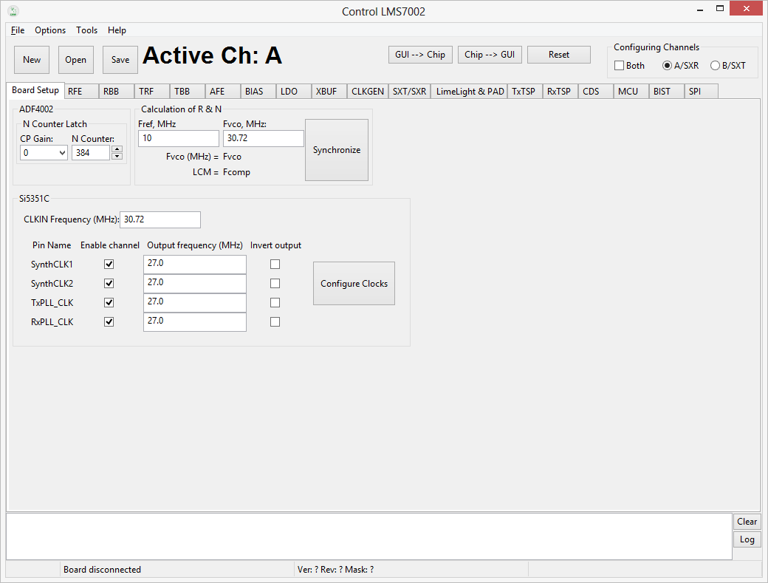
LMS7002M Registers and EVB7 Board Configuration Panel
LOG Panel
GUI Control Panel

Figure 22 GUI window diagram

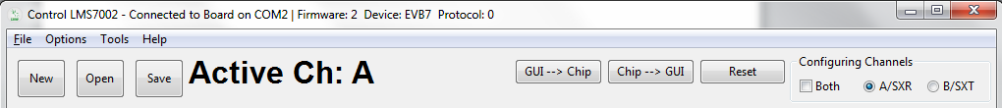

Figure 23 GUI Control Panel window

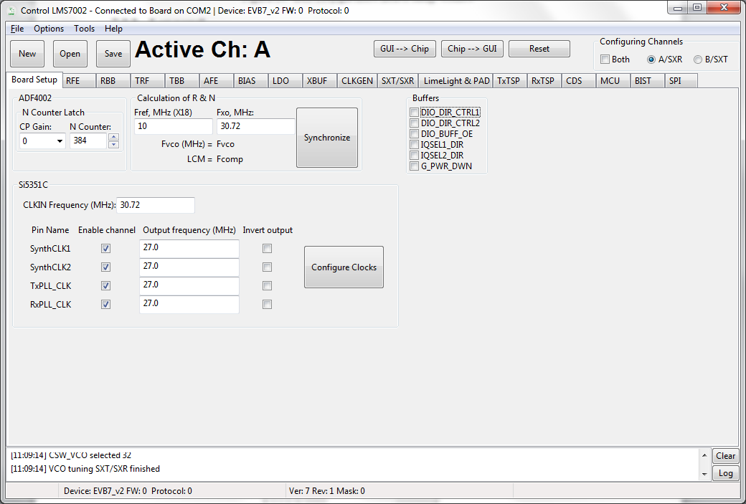

Figure 24 GUI Configuration Board Setup window

Log panel

Log panel section logs all activity executed with the GUI and is shown in Figure 25.

Figure 25 GUI Log panel

The Clear button deletes previously registered activity.

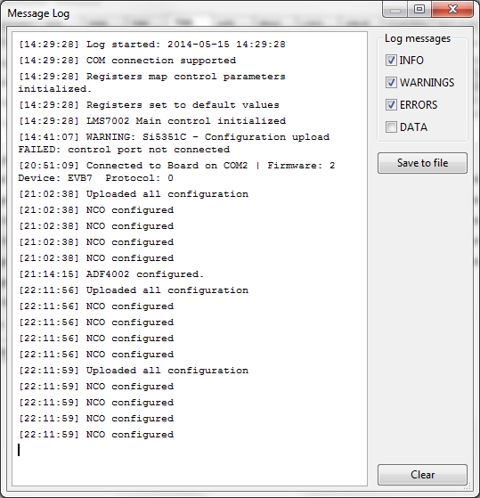
When Log button pressed, the Message Log configuration pop-up, as shown in .

Figure 26 GUI Message Log tab
This allows you to select the type of the information you want to log. The logged messages can be saved into *.txt file.

In the lower left corner of the log tab, the evaluation board version and firmware version is displayed.

The Menu Bar

The File Menu

In the File menu, you can select to start new projects, save current GUI project (saved in *.ini or *.txt format), or open previously saved project. Saved project file contains complete register setup for LMS7002M. These files can be transferred to any other computer or used as a register initialization setup for LMS7002M in baseband.

The .ini format is machine readable only.
The .txt format is human and machine readable.

The Option Menu

In the Options menu, you can select the COM port to which evaluation board is attached.

The Tool Menu

Register Map is accessible from Tools menu. When the Register Map is selected, new window will pop-up showing current LMS7002M register configuration per each channel, as shown in Figure 27.
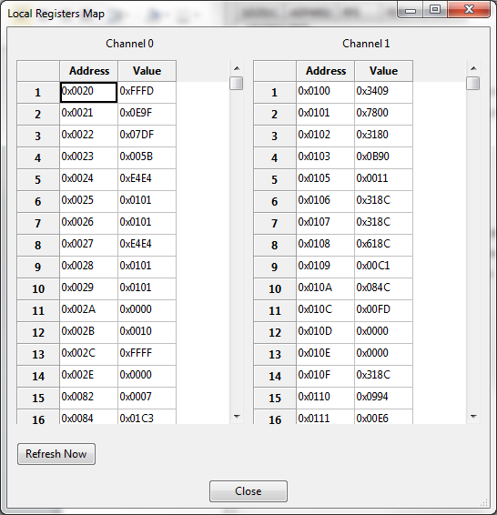
Figure 27 GUI Register Map window

The Help Menu

The help menu contains one option giving the software version and build date. It also contains the contact details for Lime Microsystems.

The Button Menu

The button menu contains 6 buttons controls and 3 other minor controls. The “new”, “open”, “save” buttons are identical to those in the “File menu” of section 1.19.1.

The RESET button performs a manual reset on the chip and updates the “LMS7002M Control” software.

To write register configuration from the “LMS7002M Control” software to the chip, press GUI→Chip button.

To read register configuration from the chip to the “LMS7002M Control” software, press Chip→GUI button.

The Configuring Channel Controls

Configuring Channels window select which channel or PLL is currently controlled. The activated channel is always displayed in a front panel:

If selected Both, front panel will display: Active Ch: SXR&SXT or Active Ch: A&B.

If selected A/SXR, front panel will display: Active Ch: SXR or Active Ch: A.

If selected B/SXT, front panel will display: Active Ch: SXT or Active Ch: B.

The display shows information depending which configuration tab you are currently and which channel is selected.

The SXR option is used for setting the receive synthesizer parameters in the SXT/SXR tab (see section 1.30). The SXT option is used for setting the transmitter synthesizer parameters in the SXT/SXR tab. The A and B channel to the A and B channels for the TX and RX MIMO channels of the RFE, RBB, TRF,TBB and AFE tabs.

Board Setup (Si5351C and ADF4002)

These tabs control two other devices on the EVB7 board.

The ADF4002 is a PLL to lock an external reference (usually 10MHz on X18) with the on board TXCO (usually 30.72MHz or 52.00MHz). This 30.72MHz reference is supplied to the LMS7002M synthesizers. This is normally used to synchronize the measurement equipment with the EVB7 board remove very minor frequency differences typically a few kHz. To synchronize board:

- Press ‘Synchronize’ button to program the ADF4002, if all is correct the green PLL locked LED (LD2) on the interface board should illuminate. LD2 is located in the upper left hand corner of the interface board.

Make sure that the Fxo value corresponds to the frequency of TCXO.

The Si5351C is a dual PLL for frequency conversion in the 10-100MHz range. It can be used to provide programmable clock signals to external hardware through the external digital interfaces and also to the LMS7002M RX and TX PLL Clocks. This allows the clock rates to be independent of the TXCO frequency. The tab is shown in Figure 28.

Figure 28 GUI Board Setup tab

By default, the EVB7 is configured to supply LMS7002M RX and TX PLL reference clock pins directly from TCXO. With a simple board modification TX and RX PLL clocks can be supplied directly from the Si5351C clock generator.

Using this feature:
- Type onboard TCXO frequency to CLKIN Frequency (MHz) window.
- Enable clock channel.
- Enter the desired output frequency.
- Press “Configure Clocks”.

The Buffers controls on board buffer directions for the LMS7002M digital interface. As well, LOGIC_RESET pin and CORE_LDO _EN pins are controlled from this window.

Table 8 GUI SPI control description
Parameter | Description
Buffers
DIO_DIR_CTRL1 | On board buffers direction control for Port 1. If selected, Port 1 is receiver.
DIO_DIR_CTRL2 | On board buffers direction control for Port 2. If selected, Port 2 is receiver.
DIO_BUFF_OE | If selected, sets onboard buffers to Hi-Impedance state.
IQSEL1_DIR | On board buffers IQSEL pin direction control for Port 1. If selected, Port 1 is receiver.
IQSEL2_DIR | On board buffers IQSEL pin direction control for Port 2. If selected, Port 2 is receiver.
G_PWR_DWN | External enable control signal for the internal LDO’s.
DIG_RST | Controls hardware pin logic reset.

RFE

RFE tab controls the RX Front End stages, including LNA selection, LNA gain, TIA gain and RX LO cancellation. A picture of the tab is shown in Figure 29. A description of each function available in this tab is shown below in Table 9.

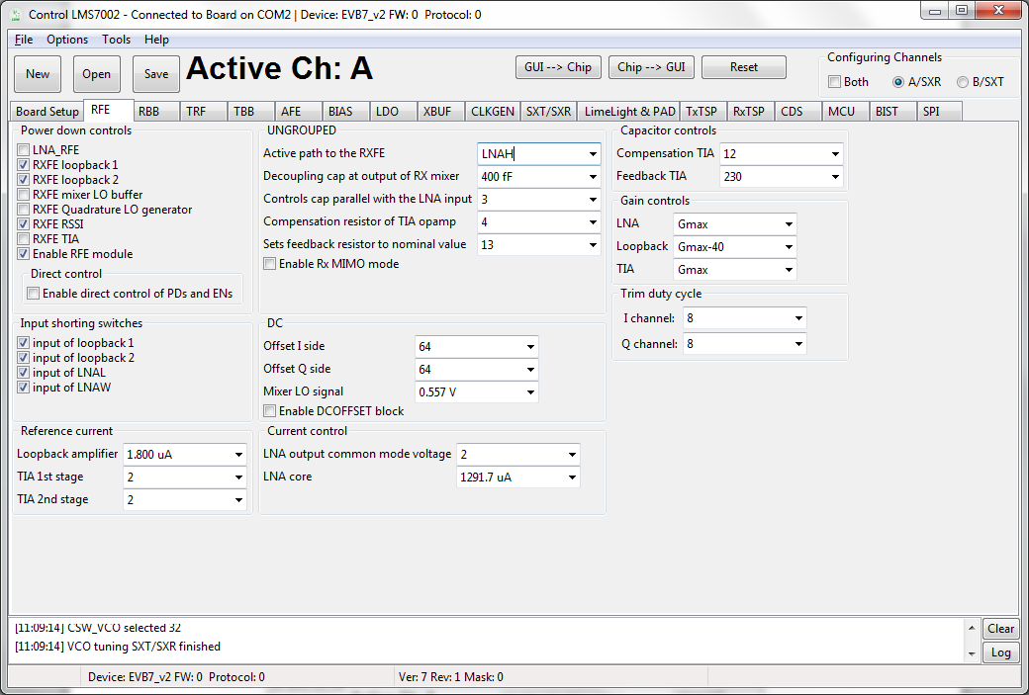

Figure 29 GUI RFE tab

Table 9 GUI RFE control description
Parameter | Description
Power down controls
LNA_RFE | Power control for LNA. Must be deselected in normal operation.
RXFE loopback1 | Power control signal for RXFE loopback to LNAL from TXRF. Used only for RF loopback.
RXFE loopback2 | Power control signal for RXFE loopback to LNAW from TXRF. Used only for RF loopback.
RXFE mixer LO buffer | Power control signal for RXFE mixer lo buffer. Must be deselected in normal operation.
RXFE Quadrature LO generator | Power control signal for RXFE quadrature LO generator. Must be deselected in normal operation.
RXFE RSSI | Power control signal for RXFE RSSI. Enables RSSI readings when powered on.
RXFE TIA | Power control signal for RXFE TIA. Must be deselected in normal operation.
Enable RFE module | Major power down for RXFE modules. All modules will be power down when deselected.
Direct control | Enables direct control of PDs and ENs for RFE. Enabled when selected.
Input shorting switches
Input of loopback 1 | Enables the input shorting switch at the input of the loopback with LNAL. Should be selected when RXFE Loopback1 is NOT active.
Input of loopback 2 | Enables the input shorting switch at the input of the loopback with LNAW. Should be selected when RXFE Loopback2 is NOT active.
Input of LNAL | Enables the input shorting switch at the input of the LNAL. Should be selected when LNAH is NOT active or during very high signal conditions.
Input of LNAW | Enables the input shorting switch at the input of the LNAW. Should be selected when LNAW is NOT active or during very high signal conditions.
Reference current
Loopback amplifier | Controls reference current of the RXFE loopback amplifier. Recommended value is 1.8uA.
TIA 1st Stage | Controls reference current of the RXFE TIA first stage. Recommended value is 2.
TIA 2nd Stage | Controls reference current of the RXFE TIA second stage. Recommended value is 2.
Capacitor controls
Compensation TIA | Compensation capacitor for TIA. Recommended value is 15.
Feedback TIA | Feedback capacitor for TIA. Controls the 3dB BW of the TIA. Recommended value is 230.
Trim Duty Cycle
I channel | Trims the duty cycle in I channel. Default value set to 8.
Q channel | Trims the duty cycle in Q channel. Default value set to 8.
UNGROUPED
Active path to the RXFE | Selects the active LNA of the RXFE between LNAL, LNAH and LNAW. Default value is no path active.
Decoupling cap at the output of RX mixer | Control the decoupling cap at the output of the RX Mixer. The capacitor range is from 80fF to 2560fF, with step size of 80 fF (32 steps). Default value is 640fF.
Controls cap parallel with the LNA input | Controls the Q of the input LNA matching circuit and provides tradeoff between gain/NF and IIP2/3. The higher the frequency, the lower value should be. Also, the higher value lower the Q. Default value is 6.
Compensation resistor of TIA opamp | Controls the compensation resistors of the TIA operational amplifier. Recommended value is 5.
Sets feedback resistor value | Sets the TIA feedback resistor value. Default vale is 13.
Enable Rx MIMO | Enable MIMO mode when MIMO is selected. If SISO is selected on Channel A is in operation.
DC
Offset I side | Controls DC offset of the I channel at the output of the TIA by injecting current to the input of the TIA. Control range from 0 to 127. Default value is 0.
Offset Q side | Controls DC offset of the Q channel at the output of the TIA by injecting current to the input of the TIA. Control range from 0 to 127. Default value is 0.
Mixer LO signal | Controls DC voltage of the mixer LO signal. Control range from 0.44V to 0.621V. Default value is 0.557V.
Enable DCOFFSET block | Enables the DC offset block for the RXFE. Select before calibrating DC offset of the Rx path
Current Control
LNA output common mode voltage | Controls the LNA output common mode voltage. Control range from 0 to 31. Default value is 2.
LNA Core | Controls the current of the LNA core. Control range from 0uA to 1291.7uA. Default value is 500uA.
Gain Controls
LNA | Controls selected LNA gain. Control range from Gmax to Gmax-30. Default value is Gmax.
Loopback | Controls RXFE loopback gain. Control range from Gmax to Gmax-40.Default value is Gmax-40dB.
TIA | Controls TIA Gain. Three gain stages: Gmax, Gmax-3dB and Gmax-12dB. Default value is Gmax.

RBB

RBB tab controls the receiver IF stage bandwidth, PGA gain and loopback.

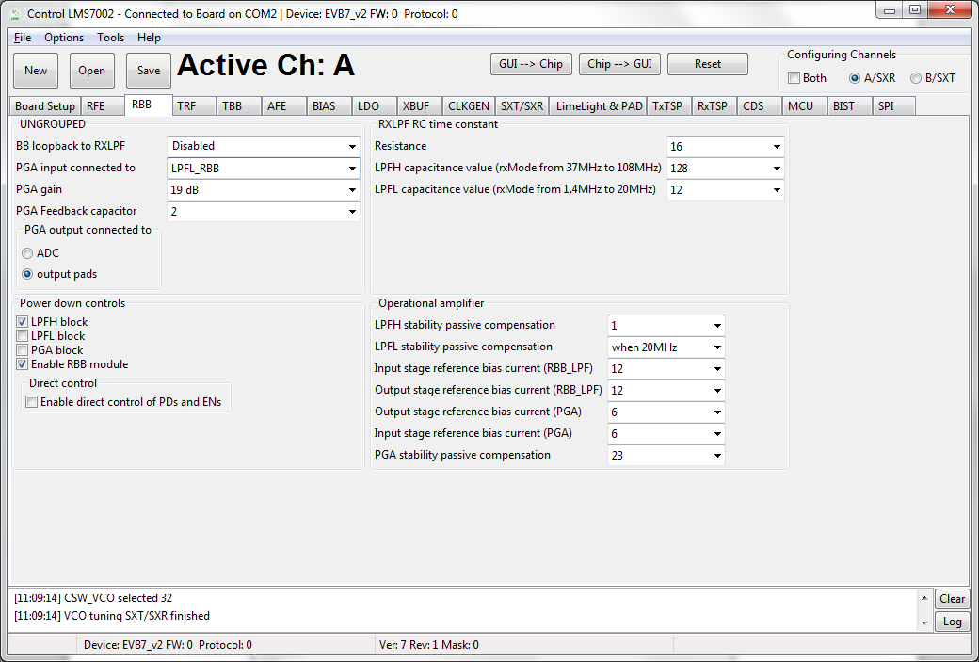

Figure 30 GUI RXBB tab

A picture of the tab is shown in Figure 30. A description of each function available in this tab is shown below in .

Table 10 GUI RXBB control description
Parameter | Description
UNGROUPED
BB loopback to RxLPF | Enables baseband loopback to high band LPF or low band LPF. Enables loopback when selected. Default value is disabled.
PGA input connected to | Controls PGA input path. There are a total five different inputs to the PGA:  - LPFL_RBB  - LPFH_RBB  - Bypass LPF  - Tx baseband loopback connected to PGA  - TXRF peak detector connected to PGA  Concurrently only one path can be selected as PGA input. Default path is LPFL output connected to PGA.
PGA gain | PGA gain control. Control range from -12dB to +19dB. Default value is -1 dB.
PGA Feedback capacitor | PGA feedback capacitor value control. Control range from 0 to 511. Default value is 2.
PGA connected to | Control PGA output switch internally directly to ADC or indirectly via the Analog output pads. Default value of PGA output is selected to ADC input.
Power down controls
LPFH block | Power down of the LPFH block. Default value block is powered down.
LPFL block | Power down of the LPFL block. Default value block is powered on.
PGA block | Power down of the PGA block. Default value block is powered on
Enable RBB module | Powers down all RBB blocks when not selected. If selected enables power down of separate RBB blocks. Default values set to enable.
Direct control | Enable direct control of PDs and ENs. Enabled when selected.
RC time constant
Resistance | Controls the absolute value of the resistance of the RC time constant in LPF. Control range from 0 to 31. The higher value selected the wider LPF BW. Default values set to 16.
LPFH capacitance value (rxMode from 37MHz to 108MHz) | Controls the capacitance value of the RC time constant of high band LPF. Control range from 0 to 255. The lower value selected the wider LPF BW. Default values set to 0.
LPFL capacitance value (rxMode from 1.4MHz to 20MHz) | Controls the capacitance value of the RC time constant of low band LPF. Control range from 0 to 255. The lower value selected the wider LPF BW. Default values set to 0. Intended to be controlled together with the TIA to maintain Chebychev response.
Operational amplifier
LPFH stability passive compensation | Controls the stability passive compensation of the LPFH operational amplifier. Control range from 0 to 7. Default values set to 0.
LPFL stability passive compensation | Controls the stability passive compensation of the LPFL operational amplifier. Control range from 0 to 5. Default values set to 5.
Input stage reference bias current (RBB_LPF) | Controls the reference bias current of the input stage of the operational amplifier used in LPF blocks (Low or High). Must increase up to 24 when a strong close blocker is detected to maintain the linearity performance. Control range from 0 to 31. Default values set to 12.
Output stage reference bias current (RBB_LPF) | Controls the reference bias current of the output stage of the operational amplifier used in LPF blocks (Low or High). Must increase up to 24 when a strong close blocker is detected to maintain the linearity performance. Control range from 0 to 31. Default values set to 12.
Output stage reference bias current (PGA) | Controls the output stage reference bias current of the operational amplifier used in the PGA circuit. Must increase up to 12 when a strong close blocker is detected or when operating at the high band frequencies to maintain the linearity performance. Control range from 0 to 31. Default values set to 6.
Input stage reference bias current (PGA) | Controls the input stage reference bias current of the operational amplifier used in the PGA circuit. Must increase up to 12 when a strong close blocker is detected or when operating at the high band frequencies to maintain the linearity performance. Control range from 0 to 31. Default values set to 6.
PGA stability passive compensation | Controls the stability passive compensation of the PGA operational amplifier. Control range from 0 to 31. Default values set to 24.

TRF

The TRF page contains the Tx front end amplifier gain controls, Tx outputs paths selection controls and all transmit block power down controls.

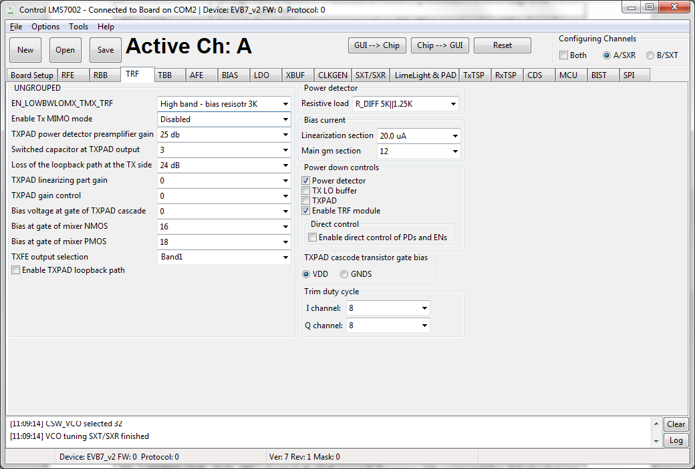

Figure 31 GUI TRF page

A picture of the tab is shown in Figure 31. A description of each function available in this tab is shown below in Table 11.

Table 11 GUI TRF control description
Parameter | Description
UNGROUPED
EN_LOWBWLOMX_TMX_TRF | Controls the high pass pole frequency of the mixer switches. Selection between low band and high band. Default is high band selection.
Enable Tx MIMO mode | Enables MIMO mode. Default is set to SISO mode.
TXPAD power detector preamplifier gain | Controls TXPAD power detector gain. Default gain is set to 25dB.
Switched capacitor at TXPAD output | Controls TXPAD output capacitor used for fine tuning. Control range from 0 to 7. Default is set to 3.
Loss of the loopback path at the TX side | Controls Tx loopback path gain. Default gain is set to -24 dB.
TXPAD linearizing part gain | Controls TXPAD linearization gain. Control range from 0 to 31. Default is set to 0.
TXPAD gain and output power | Controls the gain of TXPAD. Control range from 0 to 31. Default is set to 0 (Max gain).
Bias voltage at gate of TXPAD cascade | Controls the bias voltage at the gate of TXPAD cascade. Control range from 0 to 31. Default is set to 0.
Bias at gate of mixer NMOS | Controls the bias at the gate of the mixer NMOS switch. Control range from 0 to 31. Default is set to 28.
Bias at gate of mixer PMOS | Controls the bias at the gate of the mixer PMOS switch. Control range from 0 to 31. Default is set to 16.
TXFE output selection | Enables TXFE, Band 1 or Band 2 output. Band 1 enabled by default.
Enable TXPAD loopback path | Enables the TXPAD loopback path. Disabled by default.
Power detector
Resistive load | Controls power detector dynamic range by selecting resistive load. Default is set to 5K||1.25K.
Bias current
Linearization section | Control the bias current of the linearization section of the TXPAD. Control range from 0 to 31. Default is set to 12.
Main gm section | Control the bias current of the TXPAD. Control range from 0 to 31. Default is set to 12.
Power down controls
Power detector | Enables power detector when deselected. By default power detector is powered down.
TX LO buffers | Enables TX LO buffer. By default TX LO is enabled.
TXPAD | Enables TXPAD block. By default TXPAD is enabled
Enable TRF modules | Power down all TFE blocks when deselected. By default TRF blocks enabled.
Direct Control | Enable direct control of PDs and ENs. Enabled if selected.
TXPAD cascade transistor gate bias
VDD | TXPAD cascade transistor gate bias is referred to VDD – connect to VDD to operate.
GNDS | TXPAD cascade transistor gate bias is referred to GND.
Trim duty cycle
I channel | Trims the duty cycle in I channel. Default value set to 8.
Q channel | Trims the duty cycle in Q channel. Default value set to 8.

TBB

The TBB page controls TX IF gain settings, low-LPF and high-LPF filter bandwidths and various loopback options.

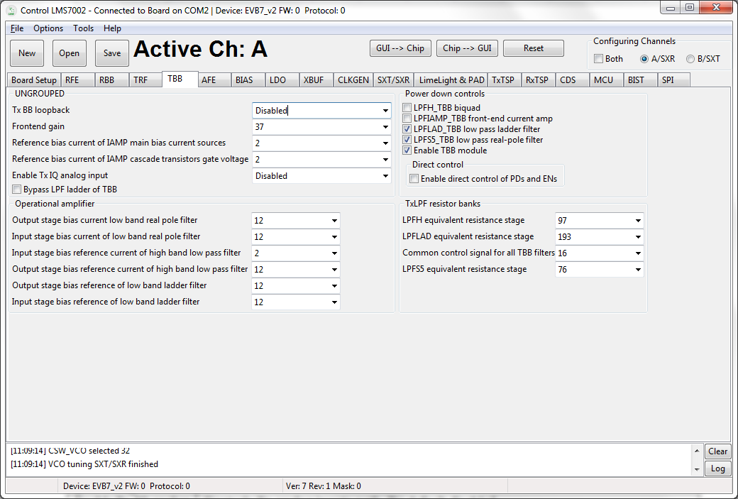

Figure 32 GUI TBB page

A picture of the tab is shown in Figure 32. A description of each function available in this tab is shown below in Table 12.

Table 12 GUI TBB control description
Parameter | Description
UNGROUPED
Tx BB Loopback | Controls the Tx BB loopback path. By default loopback is disconnected.
Frontend gain | Tx baseband stage gain control. Control range from 0 to 63. Default is set to 24.
Reference bias current of IAMP main bias current source | This controls the reference bias current of the IAMP main bias current sources. Control range from 0 to 31. Default is set to 12.
Reference bias current of IAMP cascode transistors gate voltage | This controls the reference bias current of the IAMP's cascode transistors gate voltages that set the IAMP's input voltage level. Control range from 0 to 31. Default is set to 12.
Enable Tx IQ analog input | Controls Tx analog inputs path. By default disabled.
Bypass LPF ladder of TBB | Controls TBB LPF ladder bypass mode.
Operational amplifier
Output stage bias current low band real pole filter | This controls the operational amplifier's output stage bias current. Control range from 0 to 31. Default is set to 12.
Input stage bias current low band real pole filter | This controls the operational amplifier's input stage bias current. Control range from 0 to 31. Default is set to 12
Input stage bias reference current of high band low pass filter | This controls the operational amplifiers input stage bias reference current of the high band filter. Control range from 0 to 31. Default is set to 2.
Output stage bias reference current of high band low pass filter | This controls the operational amplifiers output stage bias reference current of the high band filter. Control range from 0 to 31. Default is set to 12.
Output stage bias reference for low band ladder filter | This controls the operational amplifiers' output stages bias reference current of the low band filter. Control range from 0 to 31. Default is set to 12.
Input stage bias reference for low band ladder filter | This controls the operational amplifiers' input stages bias reference current of the low band filter. Control range from 0 to 31. Default is set to 12.
Power down controls
LPFHTBB biquad | Enables LPFH filter when deselected. By default filter is powered down.
LPFIAMP front-end current amp | Enables LPF current amplifier when deselected. By default current amplifier is enabled.
LPFLADTBB low pass ladder filter | Enables LPF ladder when deselected. By default current amplifier is enabled.
LPFS5TBB low pass real-pole filter | Enables LPF real-pole filter when deselected. By default real-pole filter is enabled.
Turn off all of TBBTOP | Enables TBB blocks once selected. By default TBB blocks are enabled.
Enable direct control of PDs and ENs | Enables direct control of PDs and ENs for TBB. Enabled when selected.
Resistor banks
LPFH equivalent resistance stage | Control LPFH bandwidth. Control range from 0 to 255. The higher number the higher bandwidth. Default setting is 0.
LPFLAD equivalent resistance stage | Control LPFL bandwidth. Control range from 0 to 255. The higher number the higher bandwidth. Default setting is 193.
Common control signal for all | A common control signal for all the capacitor banks of TBB filters. Control range from 0 to 31. Default register value set to 8.
LPFS5 equivalent resistance stage | This controls the value of the equivalent resistance of the resistor banks of the real pole filter stage. Control range from 0 to 255. Default register value set to 76.

AFE

The AFE page controls the TX and RX analog front-end interface to the digital section.

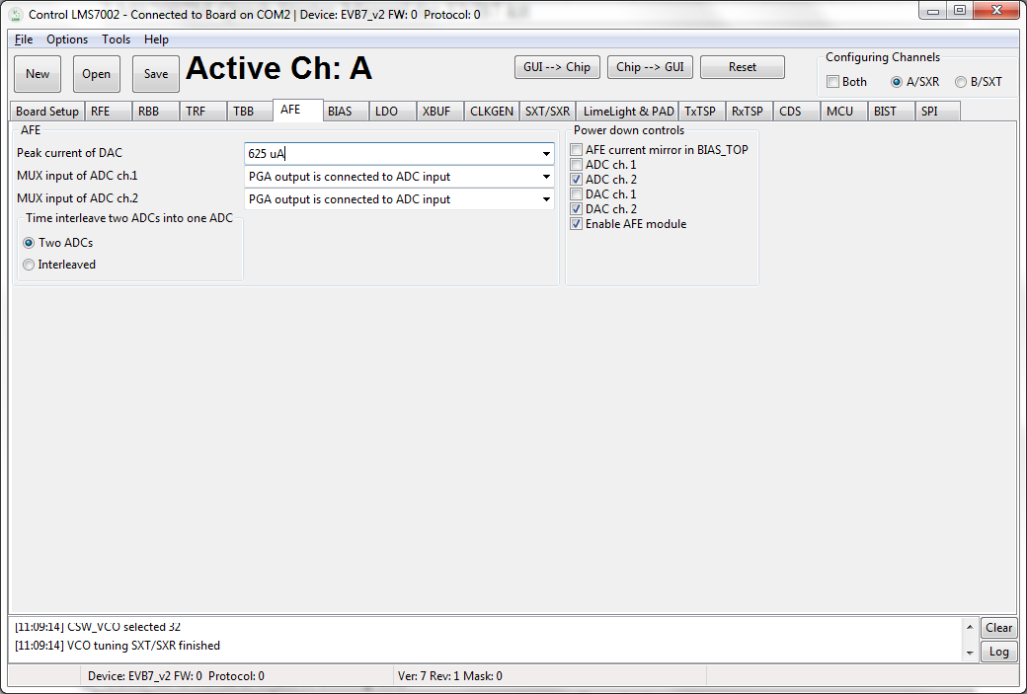
Figure 33 GUI AFE tab

A picture of the tab is shown in Figure 33. A description of each function available in this tab is shown below in Table 13.

Table 13 GUI AFE control description
Parameter | Description
AFE
Peak current of DAC | Controls the peak current of the DAC output current. By default DAC peak current set to 325uA.
MUX input of ADC ch 1. | Controls the MUX at the input of the ADC channel 1. By default MUX set to PGA output.
MUX input of ADC ch 2. | Controls the MUX at the input of the ADC channel 2. By default MUX set to PGA output.
Time interleave two analogue signals into one ADC | Default register set to Two ADC’s
Power down controls
AFE current mirror in BIASTOP | Enabled AFE current mirror in BIAS_TOP when deselected. Default current mirror is enabled.
ADC ch. 1 | Enable control of ADC of channel 1. Enabled when not selected. Enabled by default.
ADC ch. 2 | Enable control of ADC of channel 2. Enabled when not selected. Enabled by default.
DAC ch. 1 | Enable control of DAC of channel 1. Enabled when not selected. Enabled by default.
DAC ch. 2 | Enable control of DAC of channel 2. Enabled when not selected. Enabled by default.
Enable AFE module | Enabled AFE blocks when selected. By default AFE is enabled.

BIAS

The BIAS page controls the LMS7002M bias settings.

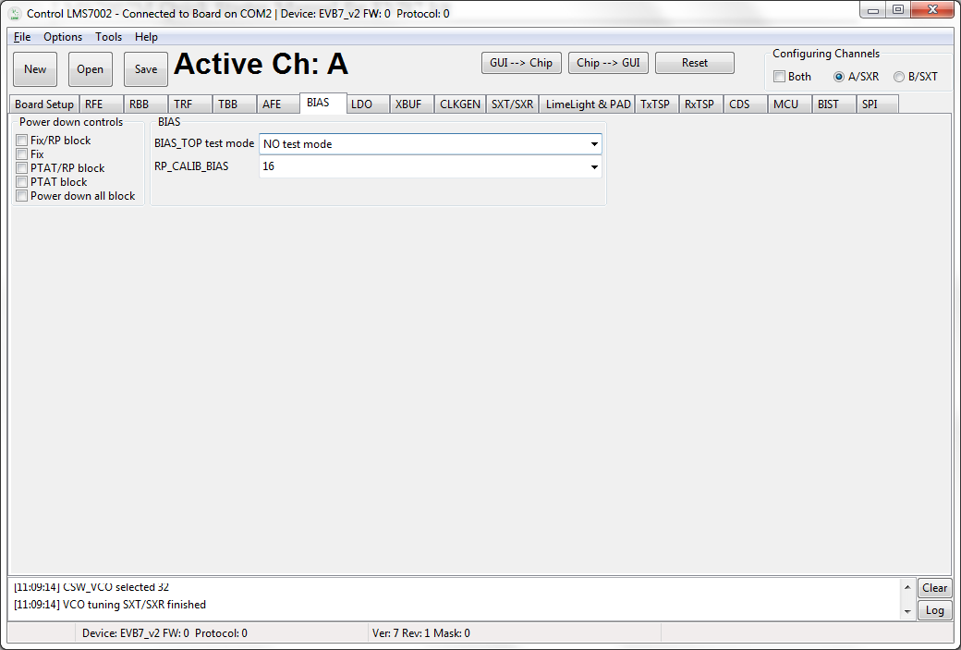

Figure 34 GUI BIAS tab

A picture of the tab is shown in Figure 34. A description of each function available in this tab is shown below in Table 14.

Table 14 GUI BIAS control description
Parameter | Description
Power down controls
Fix /RP block | Enable signal for Fix/RP block when not selected. Default register setting is set to enabled.
Fix | Enable signal for Fix block when not selected. Default register setting is set to enabled.
PTAT/RP block | Enable signal for PTAT/RP block when not selected. Default register setting is set to enabled.
PTAT | Enable signal for PTAT block when not selected. Default register setting is set to enabled.
Enable central bias block | Enable signal for central bias block. Default register setting is set to enabled.
Power down all block | Enables BIAS block when selected. By default BIAS block is enabled.
BIAS
BIASTOP test mode | Controls the test mode of the BIAS_TOP. No test mode selected by default.
RP_CALIB_bias | Control bias current calibration code. Control range from 0 to 31. Default setting is 0. This is used to set the voltage across current reference resistor R12 to 600mV – typically code 7. The “calibrate” button automatically sets this.

LDO

This tab controls the internal LDO modules. These LDO’s are used when the LMS7002M chip analog blocks supplied by single 1.8V supply. Pictures of the tab is shown in Figure 35 and Figure 36.

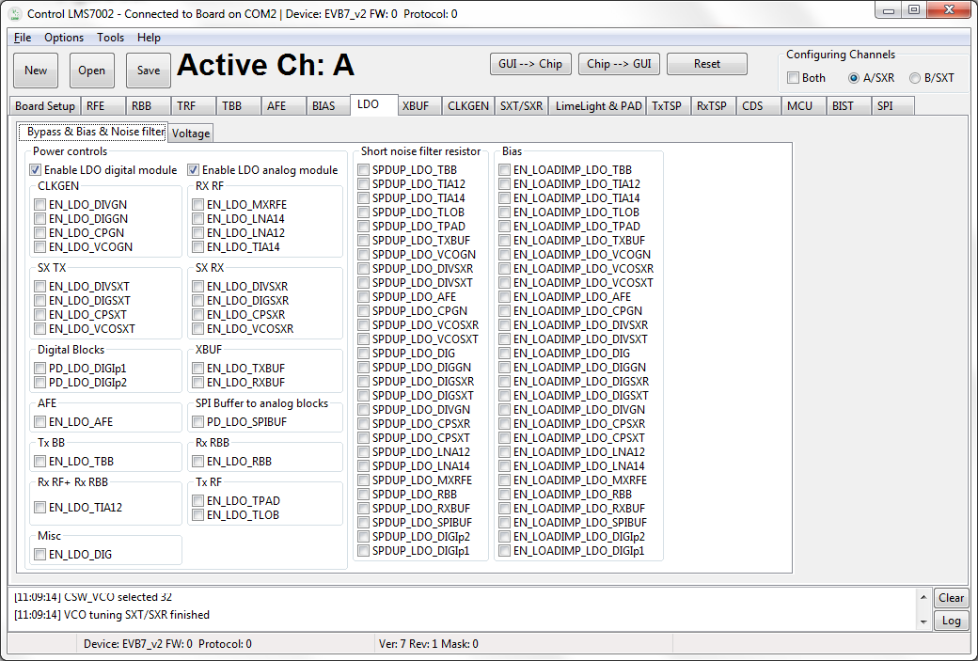

Figure 35 GUI LDO Power downs & Bias & Noise filter tab

Each 1.25V and 1.4V supply pins have internal regulators controlled via SPI interface. The LDO ’Power downs & Bias & Noise filter’ tab (figure above) divided in separate sections:
- Power control
- Short noise filter resistor
- Bias

In Power control section is the SPI controls are in groups related to their function. These controls enable the LDO for the particular block.

Short noise filter resistor bypasses noise filtering resistor. By default enabled.

Bias section enables the load dependent bias to optimize the load regulation for each LDO. This option reduces the LDO response, but increase total current consumption. Recommend to set to constant bias (not selected).

In the ‘Voltage’ tab the voltage level of the each internal LDO can be adjusted (figure below).

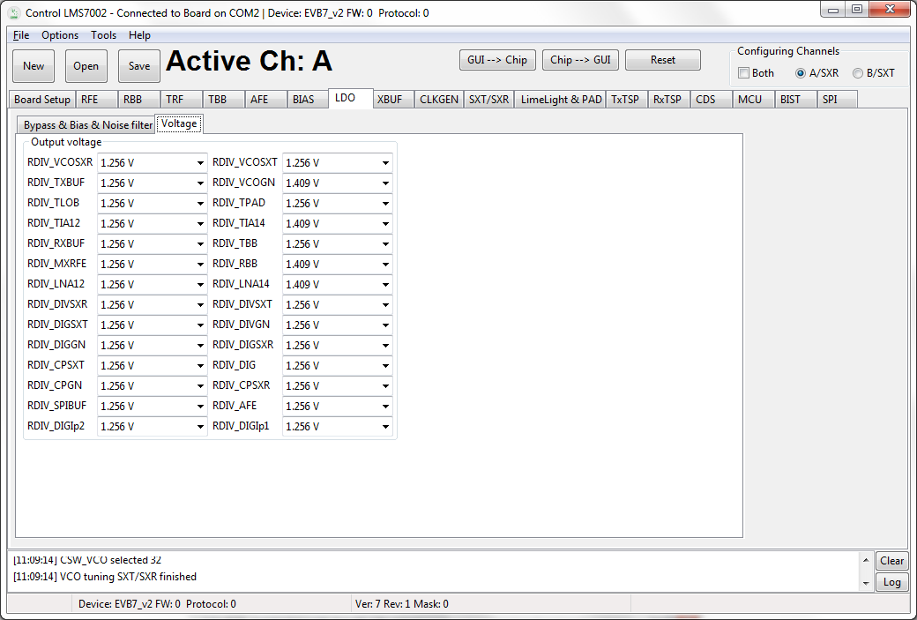

Figure 36 GUI LDO Voltages tab

XBUF

XBUF page controls the TX and RX PLL clock pin input configurations to provide a reference frequency for SXT and SXR respectively. The CLKGEN PLL uses the SXR Clock.

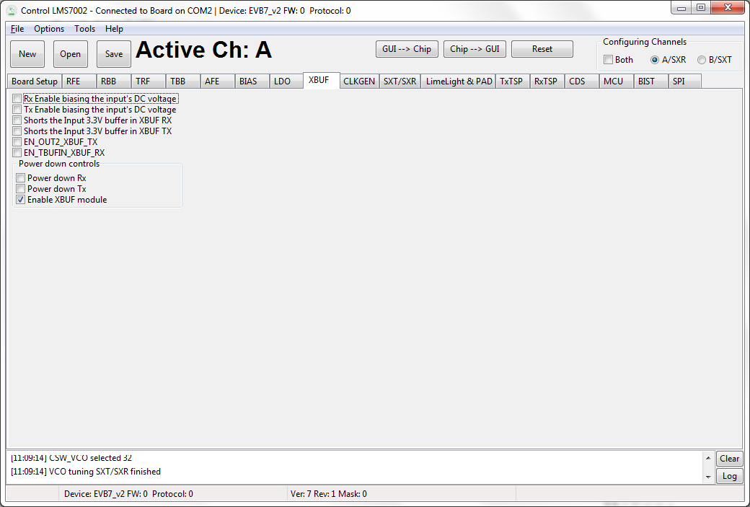

Figure 37 GUI XBUF tab

A picture of the tab is shown in Figure 37. A description of each function available in this tab is in Table 15.

Table 15 GUI XBUF control description
Parameter | Description
UNGRPUPED
Rx Enable biasing the input’s DC voltage | Receiver clock input self-biasing digital control. By default disabled. For use with AC coupled input.
Tx Enable biasing the input’s DC voltage | Transmitter clock input self-biasing digital control. By default disabled. For use with AC coupled input.
Shorts the input 3.3V buffer in XBUF RX | Shorts the Input of 3.3V buffer in XBUF. By default disabled
Shorts the input 3.3V buffer in XBUF TX | Shorts the Input of 3.3V buffer in XBUF. By default disabled
EN_OUT2_XBUF_TX | Enables the 2nd output of TX XBUF. By default buffer is disabled. This control is intended to internally rout TX PLL CLK to SXT and SXR by an internal path.
EN_TBUFIN_XBUF_RX | Disables the input from the external XO. By default buffer is disabled. This control is intended to internally rout TX PLL CLK to SXT and SXR by an internal path.
Power down controls
Power down Rx | Power down control of the Rx XBUF. Not powered down by default.
Power down Tx | Power down control of the Tx XBUF. Not powered down by default.
Enable XBUF module | Power down complete XBUF block. Enabled by default.

CLKGEN

The block diagram of the CGEN module (internal clock generator) is shown. The table in this chapter describes the control registers of the CGEN module.

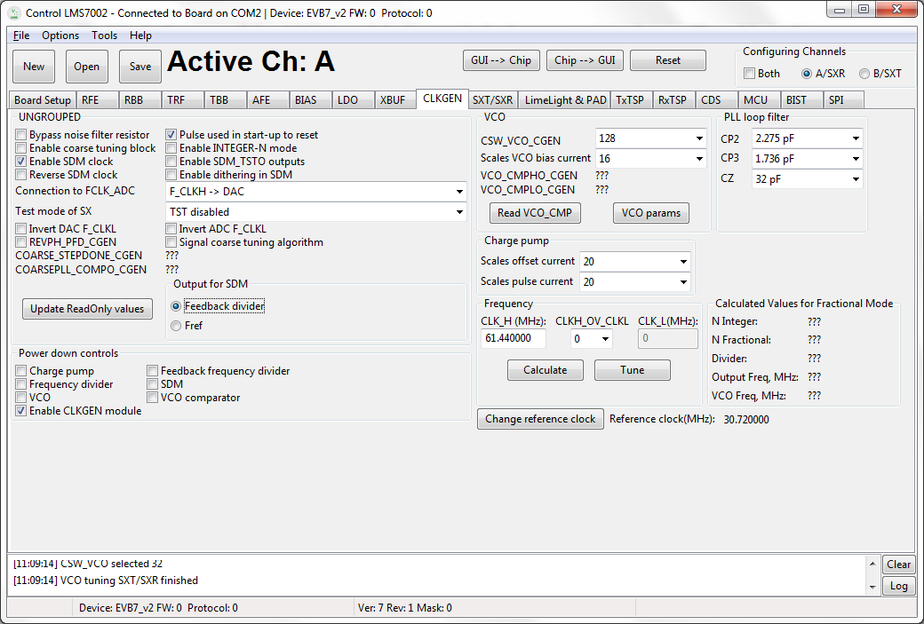

Figure 38 GUI CLKGEN tab

The internal LMS7002N CLKGEN generates clock for ADC’s, DAC’s and TSP modules. To program the CLKGEN for wanted frequency follow the step below:

- Type the wanted frequency in CLK_H (MHz) window ( default frequency is 61.44 MHz)
- Press ‘Calculate’ followed by ‘Tune’

After this procedure the digital block core will be supplied by wanted frequency. All other register are preset so no need to change.

A picture of the tab is shown in Figure 38. A description of each function available in this tab is shown below in Table 16.

Table 16 GUI CLKGEN control description
Parameter | Description
UNGROUPED
Bypass noise filter resistor | Bypasses the noise filter resistor for fast settling time. Disabled by default.
Enable coarse tuning block | Enable signal for coarse tuning block. Disabled by default.
Enable SDM clock | Enables SDM clock. Used in INT-N mode or for noise testing. Enabled by default.
Reverse SDM clock | Invert the SDM clock. By default not inverted.
Connection to FCLK_ADC | Selects if F_CLKH or F_CLKL is connected to FCLK_ADC. By default FCLK_ADC connected to F_CLKH and FCLK_DAC to F_CLKL.
Test mode of SX | Controls the test mode of the SX. Available test modes:  0: TST disabled. By default test mode disabled.  1: tstdo[0]=CLKH1 & tstdo[1]=CLKH2  2: tstdo[0]=CLK_SDM & tstdo[1]=DIV_CLK  2: tstao=vco_vtune through a 50Kohm resistor  3: tstdo[0]=REFCLK & tstdo[1]=DIV_CLK  3: tstao=vco_vtune through a 10Kohm resistor  5: tstdo[0]=PFD UP & tstdo[1]=PFD DN
Invert DAC F_CLK | Inverts the clock F_CLKL for TX TSP. By default is not inverted.
REVPH_PFD_CGEN | Inverts the pulses of PFD. It can be used to reverse the polarity of the PLL loop. By default pulse is not inverted.
Pulse used in start-up to reset | Enables pulse to reset the CLKGEN. By default set to normal operation.
Enable INTEGER-N mode | Enables INTEGER-N mode of the synthesizer. By default disabled.
Enable SDM_TSTO outputs | Enables the buffer for SDM_TSTO test outputs. Is not enabled by default.
Enable dithering in SDM | Enabled dithering. Disabled by default.
Invert ADC F_CLK | Inverts the clock F_CLKL for RX TSP. By default is not inverted.
Output for SDM | Selects between the feedback divider output and Fref for SDM. By default feedback divider is selected.
Power down controls
Charge pump | Power down control for charge pump of the CGEN block. Enabled (deselected) by default.
Frequency divider | Power down control for forward frequency divider of the CGEN block. Enabled (deselected) by default.
VCO | Power down control for VCO of the CGEN block. Enabled (deselected) by default.
Enables CLKGEN module | Power down control of the CGEN block. Enabled (selected) by default.
Feedback frequency divider | Power down control for feedback divider of the CGEN block. Enabled (deselected) by default.
SDM | Power down control for SDM of the CGEN block. Enabled (deselected) by default.
VCO comparator | Power down control for VCO comparators of the CGEN block. Enabled (deselected) by default.
VCO
CSW_VCO_CGEN | Coarse control of VCO frequency, 0 for lowest frequency and 255 for highest, by 1 step. By default set to 128.
Scales VCO bias current | Scales the VCO bias current from 0 to 2.5xInom. Control range from 0 to 31. Default value 16.
PLL filter
CP2 | Controls the value of CP2 (cap from CP output to GND) in the PLL loop filter. Control range from 0 to 5688fF. Default value 2275.2 fF.
CP3 | Controls the value of CP3 (cap from CP output to GND) in the PLL loop filter. Control range from 0 to 3720fF. Default value 1736.00 fF.
CZ | Controls the value of CP3 in the PLL loop filter. Control range from 0 to 43800fF. Default value 321200.00 fF.
Charge pump
Scales offset current | Scales the offset current of the charge pump, from 0 to 63. This current is used in Fran-N mode to create an offset in the CP response and avoid the non-linear section. Default value is set to 20.
Scales pulse current | Scales the pulse current of the charge pump, from 0 to 63. Default value is set to 20.

SXT/SXR

This tab controls the SXT and SXR modules. The table in this chapter describes the control registers of SXT and SXR modules.

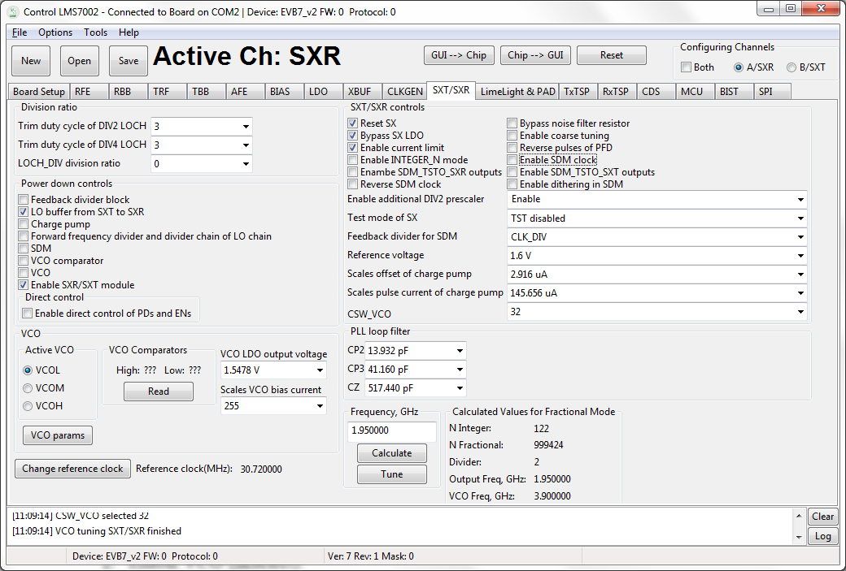

Figure 39 GUI SXT/SXR tab

Most of the SXT/SXR registers are preset to for normal (FDD) operation. To configure Tx/Rx LO to wanted frequency, do the following:

- Select the A/SXR (receiver PLL) or B/SXT (transmitter PLL) in configuration channels window accordingly which PLL frequency you want to control.
- Enable VCO (deselect).
- Type the wanted frequency in Frequency, GHz box. In this case 1950MHz.
- Press Calculate followed by Tune.

A picture of the tab is shown in Figure 39. A description of each function available in this tab is shown below in Table 17.

Table 17 GUI SXT/SXR control description
Parameter | Description
Division ration
Trim duty cycle of DIV2 LOCH | Trims the duty cycle of DIV2 LOCH. Only works when forward divider is dividing by at least 2 (excluding quadrature block division). If in bypass mode, this does not work. By default set to 3.
Trim duty cycle of DIV4 LOCH | Trims the duty cycle of DIV4 LOCH. Only works when forward divider is dividing by at least 4 (excluding quadrature block division). If in bypass mode, this does not work. By default set to 3.
LOCH_DIV division ration | Controls the division ratio in the LOCH_DIV. By default set to 2.
Power down controls
Feedback divider block | Enables PLL feedback divider. By default is enabled.
LO buffer from SXT to SXR | Power down control for LO buffer from SXT to SXR. Controlled for SXT only. To be activated only in the TDD mode. By default is disabled.
Charge pump | Power down control for Charge Pump block. By default is enabled.
Froward frequency divider and divider chain of LO chain | Power down control for feedback frequency divider and divider chain of the LO chain. By default is enabled.
SDM | Power down control for SDM block. By default is enabled.
VCO comparator | Power down control for VCO comparator block. By default is enabled.
VCO | Power down control for VCO block. By default is disabled.
Enable SXR/SXT module | Power down control for SXT/SXR block. By default enabled.
Direct control | Enabled control of PD and EN. Enabled if selected.
VCO
Active VCO | Selects the active VCO. It is set by SX_SWC calibration. By default VCOH selected.
VCO LDO output voltage | Controls VCO LDO output voltage. Control range from 0 to 255. By default set to 185.
Scales VCO bias current | Scales the VCO bias current from 0 to 2.5xInom. Control range from 0 to 255. By default set to 255.
SXT/SXR controls
Reset SX | Resets SX when enabled. A pulse should be used in the start-up to reset. By default disabled.
Bypass SX LDO | Controls the bypass signal for the SX LDO. By default LDO is bypassed.
Enable current limit | Enables the output current limitation in the VCO regulator. By default enabled.
Enable INTEGR_N mode | Enables INTEGER-N mode of the SX. By default SX is set to Frac-N mode.
Enable SDM_TSTO_SXR outputs | Enables the SDM_TSTO outputs for SXR testing purposes. By default is disabled.
Reverse SDM clock | Inverts DSM clock. By default clock is not inverted.
Reverse pulses of PFD | Inverts the pulses of PFD block. It can be used to reverse the polarity of the PLL loop. By default the clock is not inverted.
Bypass noise filter resistor | Bypasses the noise filter resistor for fast settling time. By default the speed up is not enabled.
Enable coarse tuning | Enable signal for coarse tuning block.
Enable SDM clock | Enables SDM clock. In INT-N mode or for noise destining. Enabled by default.
Enable SDM_TSTO outputs | Enables the SDM_TSTO outputs for testing purposes. By default is disabled.
Enable dithering in SDM | Enabled dithering in SDM. Disabled by default.
Enable additional DIV2 prescaler | Enables additional DIV2 prescaler at the input of the programmable divider. The core of programmable divider in the SX feedback divider works up to 5.5GHz. For FVCO>5.5GHz, the prescaler is needed to lower the input frequency. By default prescaler is not enabled.
Test mode of SX | Controls the test mode of the SX. Available test modes:  0: TST disabled. By default test mode disabled.  1: tstdo[0]=REFCLK & tstdo[1]=DIV_CLK & tstdo[2]=CLK_SDM  2: tstao[0] vco_vtune through a 50Kohm resistor  4: tstao[0] vco_vtune through a 10Kohm resistor  5: tstdo[0]=PFD UP & tstdo[1]=PFD DN
Feedback divider for SDM | Selects SDM clock input between the feedback divider output and Fref. By default feedback divider output is selected.
Reference voltage | Sets the reference voltage for varactor. By default set to 1.6V.
Scales offset of charge pump | Scales the offset current of the charge pump block. Control range from 0 to 15uA. This current is used in Fran-N mode to create an offset in the CP response and avoid the non-linear section. By default set to 2.9uA.
Scales pulse current of charge pump | Scales the pulse current of the charge pump block. Control range from 0uA to 145.6. By default set to 145.6.
PLL loop filter
CP2 | Control for CP2 value (cap from CP output to GND) of the PLL loop filter. Control range from 0fF to 34830fF. Default value 13932fF.
CP3 | Control for CP3 value (cap from CP output to GND) of the PLL loop filter. Control range from 0fF to 88200fF. Default value 41160fF.
CZ | Control for CZ value of the PLL loop filter. Control range from 0fF to 705.6fF. Default value 517.44fF.
CSW_VCO | Coarse control of VCO frequency, 0 for lowest frequency and 255 for highest. This control is set by SX_SWC calibration. Default value set to 128.

Application Note on Tuning PLLs on LMS7002M

The LMS7002M has three synthesisers: SXT, SXR and CLKGEN. The LMS7002M Control Software uses a simple tuning algorithm to control these. The minimum and maximum frequencies of each VCO are defined in the “VCO PARAMS” control for each VCO. This allows linear interpolation of CSW_VCO control when using the “Tune” control. Further frequencies could be added to the “VCO PARAMS” table to allow quadratic or cubic interpolation.

The LMS7002M also provides two comparators to detect if the VCO tuning voltage is within the recommended limits. These comparators are read with the “Read” or “Read CMP” buttons, after the “Tune” process has been carried out. When the PLL is successfully locked, the low comparator should be “1” and the high comparator “0”. If the comparators are both “0”, or both “1”, then the tuning voltage is outside the recommended range.

For best phase noise and best protection against drift the following procedure is recommended. The “Tune” button gives a nominal value for CSW_VCO. The value of CSW_VCO is manually increased until the tuning comparators report the tune voltage is out of range. The last good CSW_VCO value, CSW_VCO_{max} , is noted. Then CSW_VCO is manually decreased until the tuning comparators report that the tune voltage is out of range. The last good CSW_VCO, CSW_VCO_{min}, is also noted. The average of the two extreme CSW_VCO values is the optimum CSW_VCO_{opt} which will give good phase noise and protection against drift.

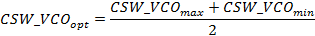

LimeLight & PAD

This tab controls the LMS7002M digital interface configuration. The IO cell controls are described in the chapter tables.

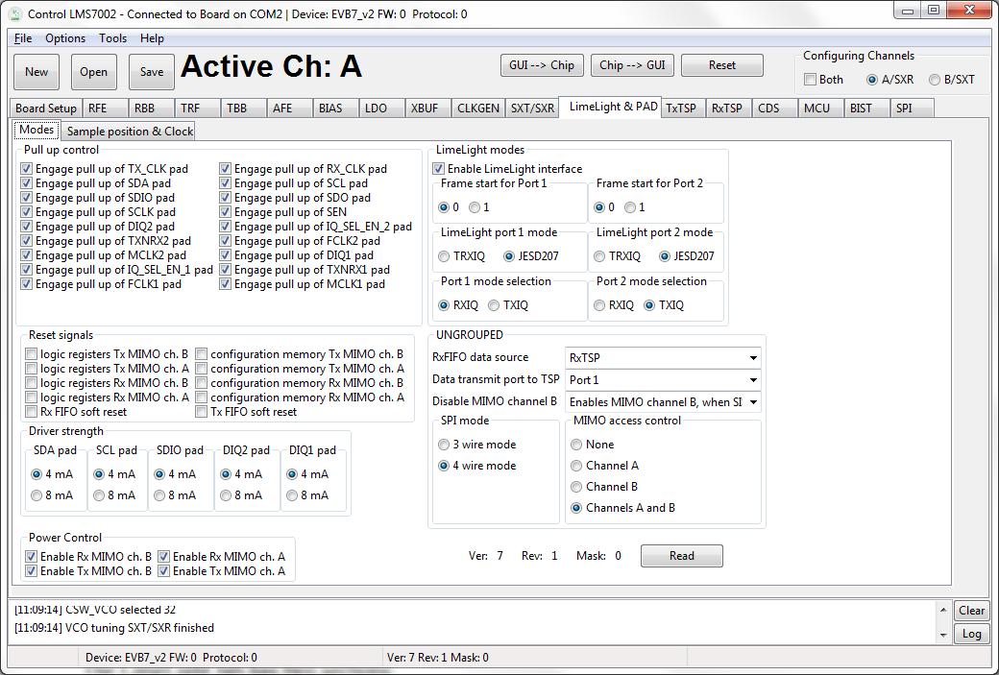

Figure 40 GUI Limelight&PAD Modes tab

The LimeLight tab has two sections:
- Modes
- Sample position & Clock

A picture of the tab is shown in Figure 40. A description of each function available in the ‘Modes’ tab is shown below in Table 18.

Table 18 GUI Limelight&PAD Modes control description
Parameter | Description
Pull up control
Engage pull up of TXCLK pad | Controls Pull up resistor of TX_CLK pad. Pull-up enabled by default.
Engage pull up of SDA pad | Controls Pull up resistor of SDA pad. Pull-up enabled by default.
Engage pull up of SDIO pad | Controls Pull up resistor of SDIO pad. Pull-up enabled by default.
Engage pull up of SCLK pad | Controls Pull up resistor of SCLK pad. Pull-up enabled by default.
Engage pull up of DIQ2 pad | Controls Pull up resistor of DIQ2 pad. Pull-up enabled by default.
Engage pull up of TXNRX2 pad | Controls Pull up resistor of TXNRX2 pad. Pull-up enabled by default.
Engage pull up of MCLK2 pad | Controls Pull up resistor of MCLK2 pad. Pull-up enabled by default.
Engage pull up of IQSELEN1 pad | Controls Pull up resistor of IQSELEN1 pad. Pull-up enabled by default.
Engage pull up of FCLK1 pad | Controls Pull up resistor of FCLK1 pad. Pull-up enabled by default.
Engage pull up of RXCLK pad | Controls Pull up resistor of RXCLK1 pad. Pull-up enabled by default.
Engage pull up of SCL pad | Controls Pull up resistor of SCL pad. Pull-up enabled by default.
Engage pull up of SDO pad | Controls Pull up resistor of SDO pad. Pull-up enabled by default.
Engage pull up of SEN pad | Controls Pull up resistor of SEN pad. Pull-up enabled by default.
Engage pull up of IQSELEN2 pad | Controls Pull up resistor of IQSELEN2 pad. Pull-up enabled by default.
Engage pull up of FCLK2 pad | Controls Pull up resistor of FCLK2 pad. Pull-up enabled by default.
Engage pull up of DIQ1 pad | Controls Pull up resistor of DIQ1 pad. Pull-up enabled by default.
Engage pull up of TXNRX1 pad | Controls Pull up resistor of TXNRX1 pad. Pull-up enabled by default.
Engage pull up of MCLK1 pad | Controls Pull up resistor of MCLK1 pad. Pull-up enabled by default.
Reset Signals
Logic registers Tx MIMO ch. B | Resets all registers to the default state for Tx MIMO channel B logic. By default RESET inactive.
Logic registers Tx MIMO ch. A | Resets all registers to the default state for Tx MIMO channel A logic. By default RESET inactive.
Logic registers Rx MIMO ch. B | Resets all registers to the default state for Rx MIMO channel B logic. By default RESET inactive.
Logic registers Rx MIMO ch. A | Resets all registers to the default state for Rx MIMO channel A logic. By default RESET inactive.
Rx FIFO soft reset | Soft reset of LimeLight RX FIFO registers. By default RESET inactive.
Configuration memory Tx MIMO ch. B | Resets configuration memory to the default state for Tx MIMO channel B logic. By default RESET inactive.
Configuration memory Tx MIMO ch. A | Resets configuration memory to the default state for Tx MIMO channel A logic. By default RESET inactive.
Configuration memory Rx MIMO ch. B | Resets configuration memory to the default state for Rx MIMO channel B logic. By default RESET inactive.
Configuration memory Rx MIMO ch. A | Resets configuration memory to the default state for Rx MIMO channel A logic. By default RESET inactive.
Tx FIFO soft reset | Soft reset of LimeLight TX FIFO registers. By default RESET inactive.
Driver strength
SDA pad | Set SDA pad driver strength to 4mA or 8 mA. By default set to 4 mA.
SCL pad | Set SCL pad driver strength to 4mA or 8 mA. By default set to 4 mA.
SDIO pad | Set SDIO pad driver strength to 4mA or 8 mA. By default set to 4 mA.
DIQ2 pad | Set DIQ2 pad driver strength to 4mA or 8 mA. By default set to 4 mA.
DIQ1 pad | Set DIQ1 pad driver strength to 4mA or 8 mA. By default set to 4 mA.
Power Control
Enable Rx MIMO ch. B | Enables Rx MIMO B channel. Enabled by default.
Enable Tx MIMO ch. B | Enables Tx MIMO B channel. Enabled by default.
Enable Rx MIMO ch. A | Enables Rx MIMO A channel. Enabled by default.
Enable Tx MIMO ch. A | Enables Tx MIMO A channel. Enabled by default.
LimeLight modes
Enable LimeLight interface | Enables LimeLight interface. By default enabled.
Frame start for Port1 | Selects frame start ID for Port 1, can be set to ‘0’ or ‘1’. By default set to ‘0’.
Frame start for Port2 | Selects frame start ID for Port 2, can be set to ‘0’ or ‘1’. By default set to ‘0’.
LimeLight port1 mode | Select mode for Port 1: T TRXIQ or JESD207. By default set to JESD207.
LimeLight port2 mode | Select mode for Port 2: T TRXIQ or JESD207. By default set to JESD207.
Port 1 mode selection | IQSEL selection for Port 1: RXIQ or TXIQ. By default set to RXIQ.
Port 2 mode selection | IQSEL selection for Port 2: RXIQ or TXIQ. By default set to TXIQ.
UNGROUPED
RxFIFO data source | RxFIFO data source selection: RxTSP, TxFIFO, LFSR. By default set to RxTSP.
Data transmit port to TSP | Port selection for data transmit to TSP.
Disable MIMO channel B | MIMO channel B enable control.
SPI mode | SPI mode control.
MIMO access control | MIMO access control.
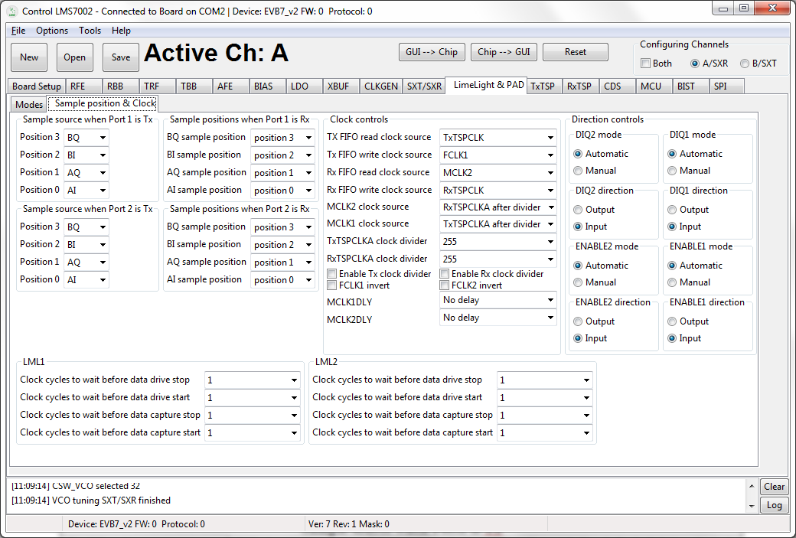

Figure 41 GUI Limelight&PAD Sample position tab

A picture of the tab is shown in Figure 41. Description of each function available from the ‘Sample position & Clock’ page is shown below in Table 19.

Table 19 GUI Limelight&PAD Sample position control description
Parameter | Description
Sample source when Port1 is Tx
Position 3 | Select sample source of the position 3: BQ, BI, AQ or AI. By default BQ is selected.
Position 2 | Select sample source of the position 2: BQ, BI, AQ or AI. By default BI is selected.
Position 1 | Select sample source of the position 1: BQ, BI, AQ or AI. By default AQ is selected.
Position 0 | Select sample source of the position 0: BQ, BI, AQ or AI. By default AI is selected.
Sample source when Port2 is Tx
Position 3 | Select sample source of the position 3: BQ, BI, AQ or AI. By default BQ is selected.
Position 2 | Select sample source of the position 2: BQ, BI, AQ or AI. By default BI is selected.
Position 1 | Select sample source of the position 1: BQ, BI, AQ or AI. By default AQ is selected.
Position 0 | Select sample source of the position 0: BQ, BI, AQ or AI. By default AI is selected.
Sample source when Port1 is Rx
BQ sample position | Select BQ sample position in frame. Position: 3, 2, 1, or 0. By default position set to 3.
BI sample position | Select BI sample position in frame. Position: 3, 2, 1, or 0. By default position set to 2.
AQ sample position | Select AQ sample position in frame. Position: 3, 2, 1, or 0. By default position set to 1.
AI sample position | Select AI sample position in frame. Position: 3, 2, 1, or 0. By default position set to 0.
Sample source when Port2 is Rx
BQ sample position | Select BQ sample position in frame. Position: 3, 2, 1, or 0. By default position set to 3.
BI sample position | Select BI sample position in frame. Position: 3, 2, 1, or 0. By default position set to 2.
AQ sample position | Select AQ sample position in frame. Position: 3, 2, 1, or 0. By default position set to 1.
AI sample position | Select AI sample position in frame. Position: 3, 2, 1, or 0. By default position set to 0.
Clock controls
TX FIFO read clock source | Select TX FIFO read clock source: TxTSPCLK, FCKL1 or FCKL2. By default TxTSPCLK is selected.
TX FIFO write clock source | Select TX FIFO write clock source: FCKL1, FCKL2 or RxTSPCLK. By default FCKL1 is selected.
RX FIFO read clock source | Select RX FIFO read clock source: MCKL1, MCKL2, FCKL1 or FCKL2. By default MCKL2 is selected.
RX FIFO write clock source | Select RX FIFO write clock source: FCKL1, FCKL2 or RxTSPCLK. By default RxTSPCLK is selected.
MCLK2 clock source | Select MCKL2 clock source from: RxTSPCLKA, TxTSPCLKA, RxTSPCLKA after divider or TxTSPCLKA after divider. By default RxTSPCLK after divider is selected.
MCLK1 clock source | Select MCKL1 clock source from: RxTSPCLKA, TxTSPCLKA, RxTSPCLKA after divider or TxTSPCLKA after divider. By default TxTSPCLK after divider is selected.
TxTSPCLKA clock divider | TxTSP clock divider, used to produce MCLK(1/2) clocks. Control range from 0 to 255. By default set to 255.
RxTSPCLKA clock divider | RxTSP clock divider, used to produce MCLK(1/2) clocks. Control range from 0 to 255. By default set to 255.
Enable Tx clock divider | Enables Tx clock divider. Set to enable by default.
FCLK1 invert | Inverts FCLK1 clock. By default clock is not inverted.
Enable Rx clock divider | Enables Rx clock divider. Set to enable by default.
FCLK2 invert | Inverts FCLK1 clock. By default clock is not inverted.
MCLK1DLY | Select MCLK1 clock delay. By default clock not delayed.
MCLK2DLY | Select MCLK2 clock delay. By default clock not delayed.
Direction controls
DIQ2 mode | DIQ2 direction control mode. By default set to Automatic.
DIQ1 mode | DIQ1 direction control mode. By default set to Automatic.
DIQ2 direction | DIQ2 direction. By default set to Input.
DIQ1 direction | DIQ1 direction. By default set to Input.
ENABLE2 mode | ENABLE2 direction control mode. By default set to Automatic.
ENABLE1 mode | ENABLE1 direction control mode. By default set to Automatic.
ENABLE2 direction | ENABLE2 direction. By default set to Input.
ENABLE1 direction | ENABLE1 direction. By default set to Input.
LML1
Clock cycles to wait before data drive stop | Controls the number of clock cycles to wait before data drive stop after burst stop is detected in JESD207 mode on Port 1 and Port 1 is transmitter. By default set to 1.
Clock cycles to wait before data drive start | Controls the number of clock cycles to wait before data drive stop after burst start is detected in JESD207 mode on Port 1 and Port 1 is transmitter. By default set to 1.
Clock cycles to wait before data capture stop | Controls the number of clock cycles to wait before data capture stop after burst stop is detected in JESD207 mode on Port 1 and Port 1 is receiver. By default set to 1.
Clock cycles to wait before data capture stop | Controls the number of clock cycles to wait before data capture stop after burst start is detected in JESD207 mode on Port 1 and Port 1 is receiver. By default set to 1.
LML2
Clock cycles to wait before data drive stop | Controls the number of clock cycles to wait before data drive stop after burst stop is detected in JESD207 mode on Port 1 and Port 1 is transmitter. By default set to 1.
Clock cycles to wait before data drive start | Controls the number of clock cycles to wait before data drive stop after burst start is detected in JESD207 mode on Port 1 and Port 1 is transmitter. By default set to 1.
Clock cycles to wait before data capture stop | Controls the number of clock cycles to wait before data capture stop after burst stop is detected in JESD207 mode on Port 1 and Port 1 is receiver. By default set to 1.
Clock cycles to wait before data capture stop | Controls the number of clock cycles to wait before data capture stop after burst start is detected in JESD207 mode on Port 1 and Port 1 is receiver. By default set to 1.
Direction controls
DIQ2 mode | DIQ2 direction control mode for port 2. Set to Automatic by default.
DIQ1 mode | DIQ1 direction control mode for port 1. Set to Automatic by default.
DIQ2 direction | DIQ2 direction. Set to input by default.
DIQ1 direction | DIQ1 direction. Set to input by default.
ENABLE2 mode | ENABLE2 direction control mode. Set to Automatic by default.
ENABLE1 mode | ENABLE1 direction control mode. Set to Automatic by default.
ENABLE2 direction | ENABLE2 direction. Set to input by default.
ENABLE1 direction | ENABLE1 direction. Set to input by default.

TxTSP

The Tx_TSP tab controls the digital blocks of TxTSPA and TxTSPB modules.

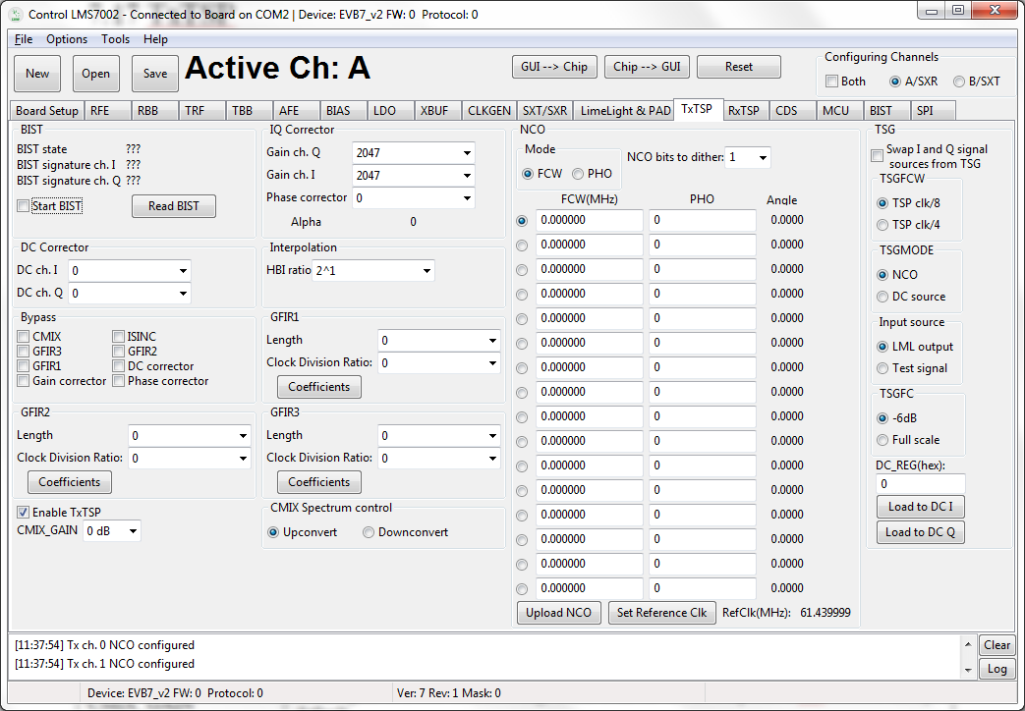

Figure 42 GUI TxTSP tab

A picture of the tab is shown in Figure 42. A description of each function available in this tab is shown below in Table 20.

Table 20 GUI TxTSP control description
Parameter | Description
Enable TxTSP | Enables TxTSP modules enable. Enabled by default.
CMIX_GAIN | CMIX gain control. Control range from -6 dB to +6d B. Step size 6 dB. Set to 0 dB by default.
CMIX Spectrum control | Spectrum control of CMIX. By default set to downconvert.
Start BIST | Starts TxTSP built-in self-test. Keep it at 1 one at least three clock cycles.
Bypass
CMIX | Bypass CMIX module when selected.
GFIR3 | Bypass GFIR3 module when selected.
GFIR1 | Bypass GFIR1 module when selected.
Gain correction | Bypass Gain correction module when selected.
ISINC | Bypass ISINC module when selected.
GFIR2 | Bypass GFIR2 module when selected.
DC Correction | Bypass DC correction module when selected.
Phase correction | Bypass Phase correction module when selected.
GFIR1
Length | Set GFIR parameter I. Control range from 0 to 7.
Clock Division Ration | Sets GFIR filter clock division ration. Control range from 0 to 255.
Coefficients | Sets/Load GFIR filters coefficients. By default all set to 0.
GFIR2
Length | Set GFIR parameter I. Control range from 0 to 7.
Clock Division Ration | Sets GFIR filter clock division ration. Control range from 0 to 255.
Coefficients | Sets/Load GFIR filters coefficients. By default all set to 0.
GFIR3
Length | Set GFIR parameter I. Control range from 0 to 7.
Clock Division Ration | Sets GFIR filter clock division ration. Control range from 0 to 255.
Coefficients | Sets/Load GFIR filters coefficients. By default all set to 0.
DC Corrector
DC ch. I | Sets DC corrector value to channel I. Control range from -128 to 128. By default 0.
DC ch. Q | Sets DC corrector value to channel Q. Control range from -128 to 128. By default 0.
IQ Corrector
Gain ch. Q | Sets Gain corrector value to channel Q. Control range from 0 to 2047. By default 2047.
Gain ch. I | Sets Gain corrector value to channel I. Control range from 0 to 2047. By default 2047.
Phase corrector | Sets Phase corrector value. Control range from 0 to 2047. By default 0.
Interpolation
HBI ratio | Sets HBI interpolation ratio. Possible control values 2, 4, 8, 16, 32 and bypass. By default bypassed.
TSG
Swap I and Q signal | Swap IQ signals at test signal generator's output. By default not selected.
TSGFCW | Select frequency generated by test NCO. By default TSG frequency set to the TSP clock divided by 8.
TSGMODE | Select test signal generator mode: NCO or DC. By default NCO is selected.
Input Source | Select input source to TSP: LML output or TSG. By default LML output is selected.
TSGC | TSG full scale control: 0 dB or -6 dB. By default set to -6 dB.
Load DC to I | Load TSG DC I register with value from DC_REG (hex) box.
Load ED to Q | Load TSG DC Q register with value from DC_REG (hex) box.
NCO
Mode | Selects the CW or PHO (Phase offset) mode for NCO.
NCO bits to dither | Selects number of bits for NCO dithering.
FCW(MHz) | Type wanted NCO frequency.
Set reference frequency | Set reference frequency for NCO. The frequency the same as TSP block.
Upload NCO | Program NCO

RxTSP

The Rx_TSP tab controls the digital blocks of RxTSPA and RxTSPB modules. A picture of the tab is shown in Figure 43. A description of each function available in this tab is shown below in Table 21.

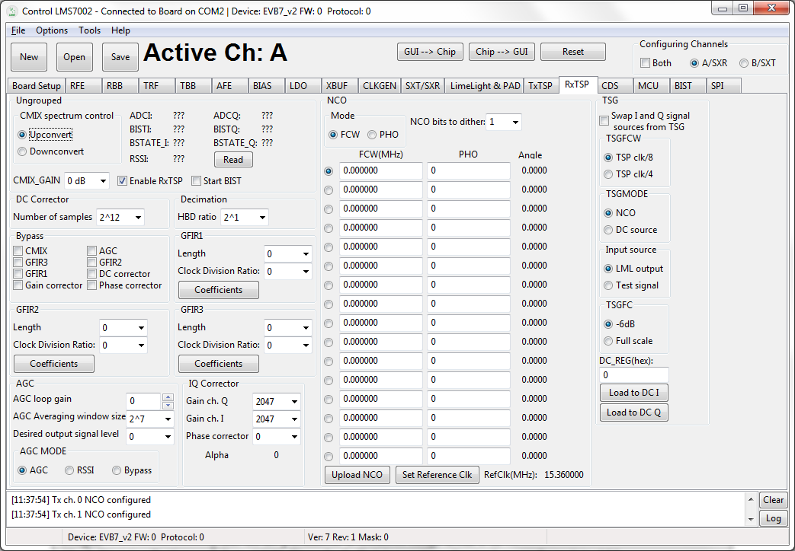

Figure 43 GUI RxTSP tab

Table 21 GUI RxTSP control description
Parameter | Description
Enable RxTSP | Enables TxRSP modules enable. Enabled by default.
CMIX_GAIN | CMIX gain control. Control range from -6 dB to +6 dB. Step size 6 dB. Set to 0 dB by default.
CMIX Spectrum control | Spectrum control of CMIX. By default set to downconvert.
Start BIST | Starts RxTSP built-in self-test. Keep it at 1 one for at least three clock cycles
Bypass
CMIX | Bypass CMIX module when selected.
GFIR3 | Bypass GFIR3 module when selected.
GFIR1 | Bypass GFIR1 module when selected.
Gain correction | Bypass Gain correction module when selected.
AGC | Bypass AGC module when selected.
GFIR2 | Bypass GFIR2 module when selected.
DC Correction | Bypass DC corrector module when selected.
Phase correction | Bypass Phase corrector module when selected.
GFIR1
Length | Set GFIR parameter I. Control range from 0 to 7.
Clock Division Ration | Sets GFIR filter clock division ration. Control range from 0 to 255.
Coefficients | Sets/Load GFIR filters coefficients. By default all set to 0.
GFIR2
Length | Set GFIR parameter I. Control range from 0 to 7.
Clock Division Ration | Sets GFIR filter clock division ration. Control range from 0 to 255.
Coefficients | Sets/Load GFIR filters coefficients. By default all set to 0.
GFIR3
Length | Set GFIR parameter I. Control range from 0 to 7.
Clock Division Ration | Sets GFIR filter clock division ration. Control range from 0 to 255.
Coefficients | Sets/Load GFIR filters coefficients. By default all set to 0.
DC Corrector
Numbers of samples | Select the number of samples to average for Automatic DC corrector.
IQ Corrector
Gain ch. Q | Sets Gain corrector value to channel Q. Control range from 0 to 2047. By default 2047.
Gain ch. I | Sets Gain corrector value to channel I. Control range from 0 to 2047. By default 2047.
Phase corrector | Sets Phase corrector value. Control range from 0 to 2047. By default 0.
Decimation
HBD ratio | Sets HBD interpolation ratio. Possible control values 2, 4, 8, 16, 32 and bypass. By default bypassed.
TSG
Swap I and Q signal | Swap IQ signals at test signal generator's output. By default not selected.
TSGFCW | Select frequency generated by test NCO. By default TSG frequency set to the TSP clock divided by 8.
TSGMODE | Select test signal generator mode: NCO or DC. By default NCO is selected.
Input Source | Select input source to TSP: ADC input or TSG. By default LML output is selected.
TSGC | TSG full scale control: 0 dB or -6 dB. By default set to -6 dB.
Load DC to I | Load TSG DC I register with value from DC_REG (hex) box.
Load ED to Q | Load TSG DC Q register with value from DC_REG (hex) box.
NCO
Mode | Selects the CW or PHO (Phase offset) mode for NCO.
NCO bits to dither | Selects number of bits for NCO dithering.
FCW(MHz) | Type wanted NCO frequency.
PHO | Type wanted PHO frequency.
Set reference frequency | Set reference frequency for NCO. The frequency is the same as the TSP block.
Upload NCO | Program NCO
AGC
AGC Mode | Selects the AGC mode: Bypass, AGC, RSSI mode.
AGC loop gain | Selects AGC loop gain.
AGC Average window size | AGC averaging window size is 2^{(AGC_AVG + 7)}.
Desired output level | Selects desired output signal level

CDS

The Clock Distribution System (CDS) controls are described in this this chapter.

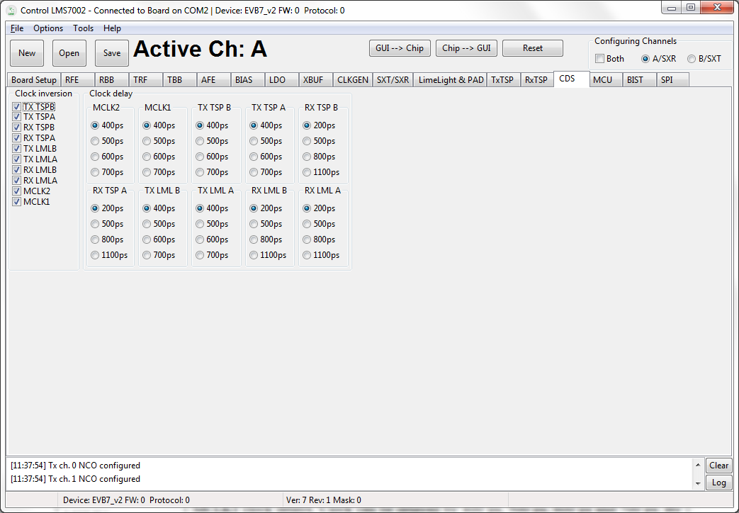

Figure 44 GUI CDS tab

A picture of the tab is shown in Figure 44. A description of each function available in this tab is shown below in Table 21.

Table 22 GUI CDS control description
Parameter | Description
Clock inversion
TX TSPB | TX TSP B channel clock inversion controls. By default clock is not inverted.
TX TSPA | TX TSP A channel clock inversion controls. By default clock is not inverted.
RX TSPB | RX TSP B channel clock inversion controls. By default clock is not inverted.
RX TSPA | RX TSP A channel clock inversion controls. By default clock is not inverted.
TX LMLB | TX LML interface B channel clock inversion control. By default clock is not inverted.
TX LMLA | TX LML interface A channel clock inversion control. By default clock is not inverted.
RX LMLB | RX LML interface B channel clock inversion control. By default clock is not inverted.
RX LMLA | RX LML interface A channel clock inversion control. By default clock is not inverted.
MCKL2 | MCLK2 clock inversion control. By default clock is not inverted.
MCKL1 | MCLK1 clock inversion control. By default clock is not inverted.
Clock delay
MCLK2 | MCLK2 clock delays. Clock can be delayed by 400 ps, 500 ps, 600 ps and 700 ps. By default clock delayed 400 ps.
MCLK1 | MCLK1 clock delays. Clock can be delayed by 400 ps, 500 ps, 600 ps and 700 ps. By default clock delayed 400 ps.
TX TSP B | TX TSP B clock delays. Clock can be delayed by 400 ps, 500 ps, 600 ps and 700 ps. By default clock delayed 400 ps.
TX TSP A | TX TSP A clock delays. Clock can be delayed by 400 ps, 500 ps, 600 ps and 700 ps. By default clock delayed 400 ps.
RX TSP B | RX TSP B clock delay. Clock can be delayed by 200 ps, 500 ps, 800 ps and 1100 ps. By default clock delayed 200 ps.
RX TSP A | RX TSP A clock delay. Clock can be delayed by 200 ps, 500 ps, 800 ps and 1100 ps. By default clock delayed 200 ps.
TX LML B | TX LML B clock delay. Clock can be delayed by 400 ps, 500 ps, 600 ps and 700 ps. By default clock delayed 400 ps.
TX LML A | TX LML A clock delay. Clock can be delayed by 400 ps, 500 ps, 600 ps and 700 ps. By default clock delayed 400 ps.
RX LML B | RX LML B clock delay. Clock can be delayed by 200 ps, 500 ps, 800 ps and 1100 ps. By default clock delayed 200 ps.
RX LML A | RX LML A clock delay. Clock can be delayed by 200 ps, 500 ps, 800 ps and 1100 ps. By default clock delayed 200 ps.

BIST

The Build-In Self-Test (BIST) modules for SXT, SXR and CGEN controls are described in this chapter.

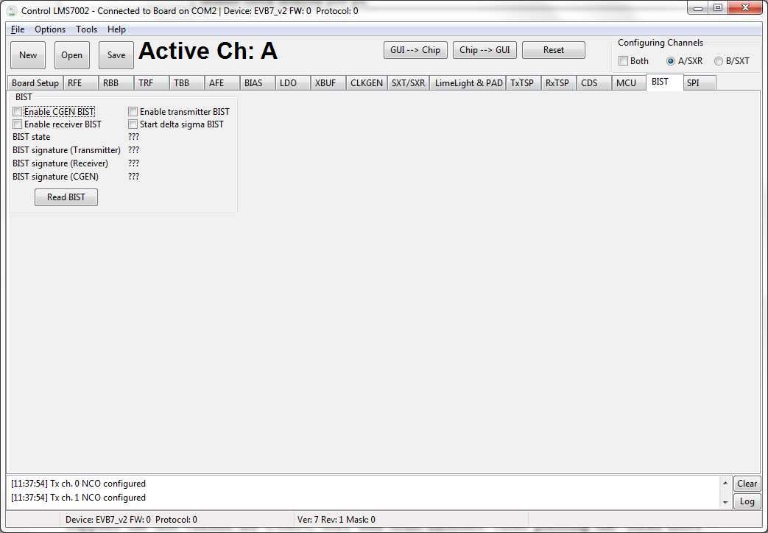

Figure 45 GUI BIST tab

The BIST modules are used for the test proposes only. There is one test vector generator which supplies the test vectors for CGEN, SXT and SXR modules. After pressing the ‘Read BIST’ button the test results (test vector signature) will be displayed for the selected block.

A picture of the tab is shown in Figure 45. A description of each function available in this tab is shown below in Table 23.

Table 23 GUI BIST control description
Parameter | Description
BIST
Enable CGEN BIST | Enables CGEN BIST. Disabled by default.
Enable receiver BIST | Enables SXR BIST. Disabled by default.
Enable transmitter BIST | Enables SXT BIST. Disabled by default.
Start delta sigma BIST | Enables delta sigma BIST. Disabled by default.

SPI

This is used for test proposes only. Using this tab, every SPI register can be programmed using the register map description. Every SPI register of the LMS7002M can be read back. A picture of the tab is shown in Figure 46. A description of each function available in this tab is shown below in Table 24.

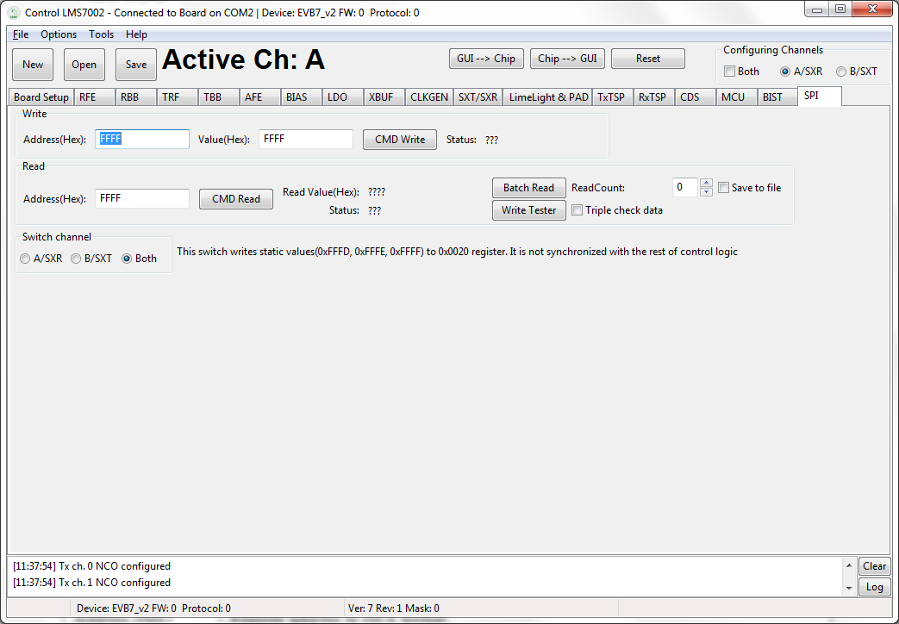

Figure 46 GUI SPI tab

Table 24 GUI SPI control description
Parameter | Description
Write
Address (Hex) | Register address in HEX format.
Value (Hex) | Register value in HEX format.
Status | Previously executed command status.
Read
Address (Hex) | Register address in HEX format.
Read Values (Hex) | Register value in HEX format.
Status | Previously executed command status.
Batch Read | Executes multiple reads from selected register. The read number selected by ReadCount.
ReadCount | Set read back function count number.
Write Tester | Writes and read to selected register 100 times.
Triple check data | When selected repeats function three times.
Save to file | If selected save function results to txt file to selected location.
Switch channel | Selects read/write channel.

Appendix A: Test Equipment Setup

Introduction

This section lists the recommended test equipment to use with the EVB7. It also provides detailed setup procedures for the Agilent MXG when used with EVB7. Note the set up procedure is only required when using the analogue TX inputs of the LMS7002M. This procedure is not required when the LMS7002M chip is driven digitally by a baseband processor.

Recommended Test Equipment

The following test equipment is recommended for the testing of EVB7. It is possible to use other test equipment, but the alternatives may not provide all the necessary features.

- N5182A MXG
  - Differential Arbitrary Waveform Generator Option 1EL
- N9020A MXA DC - 6 GHz
  - NF personality
  - Phase Noise personality
  - WCDMA personality
  - LTE personality
- Agilent Power Supply 5V
- Agilent 384C Noise Source
  - 15 dB ENR

Agilent MXG Setup

The front panel of the MXG is shown in Figure 47.

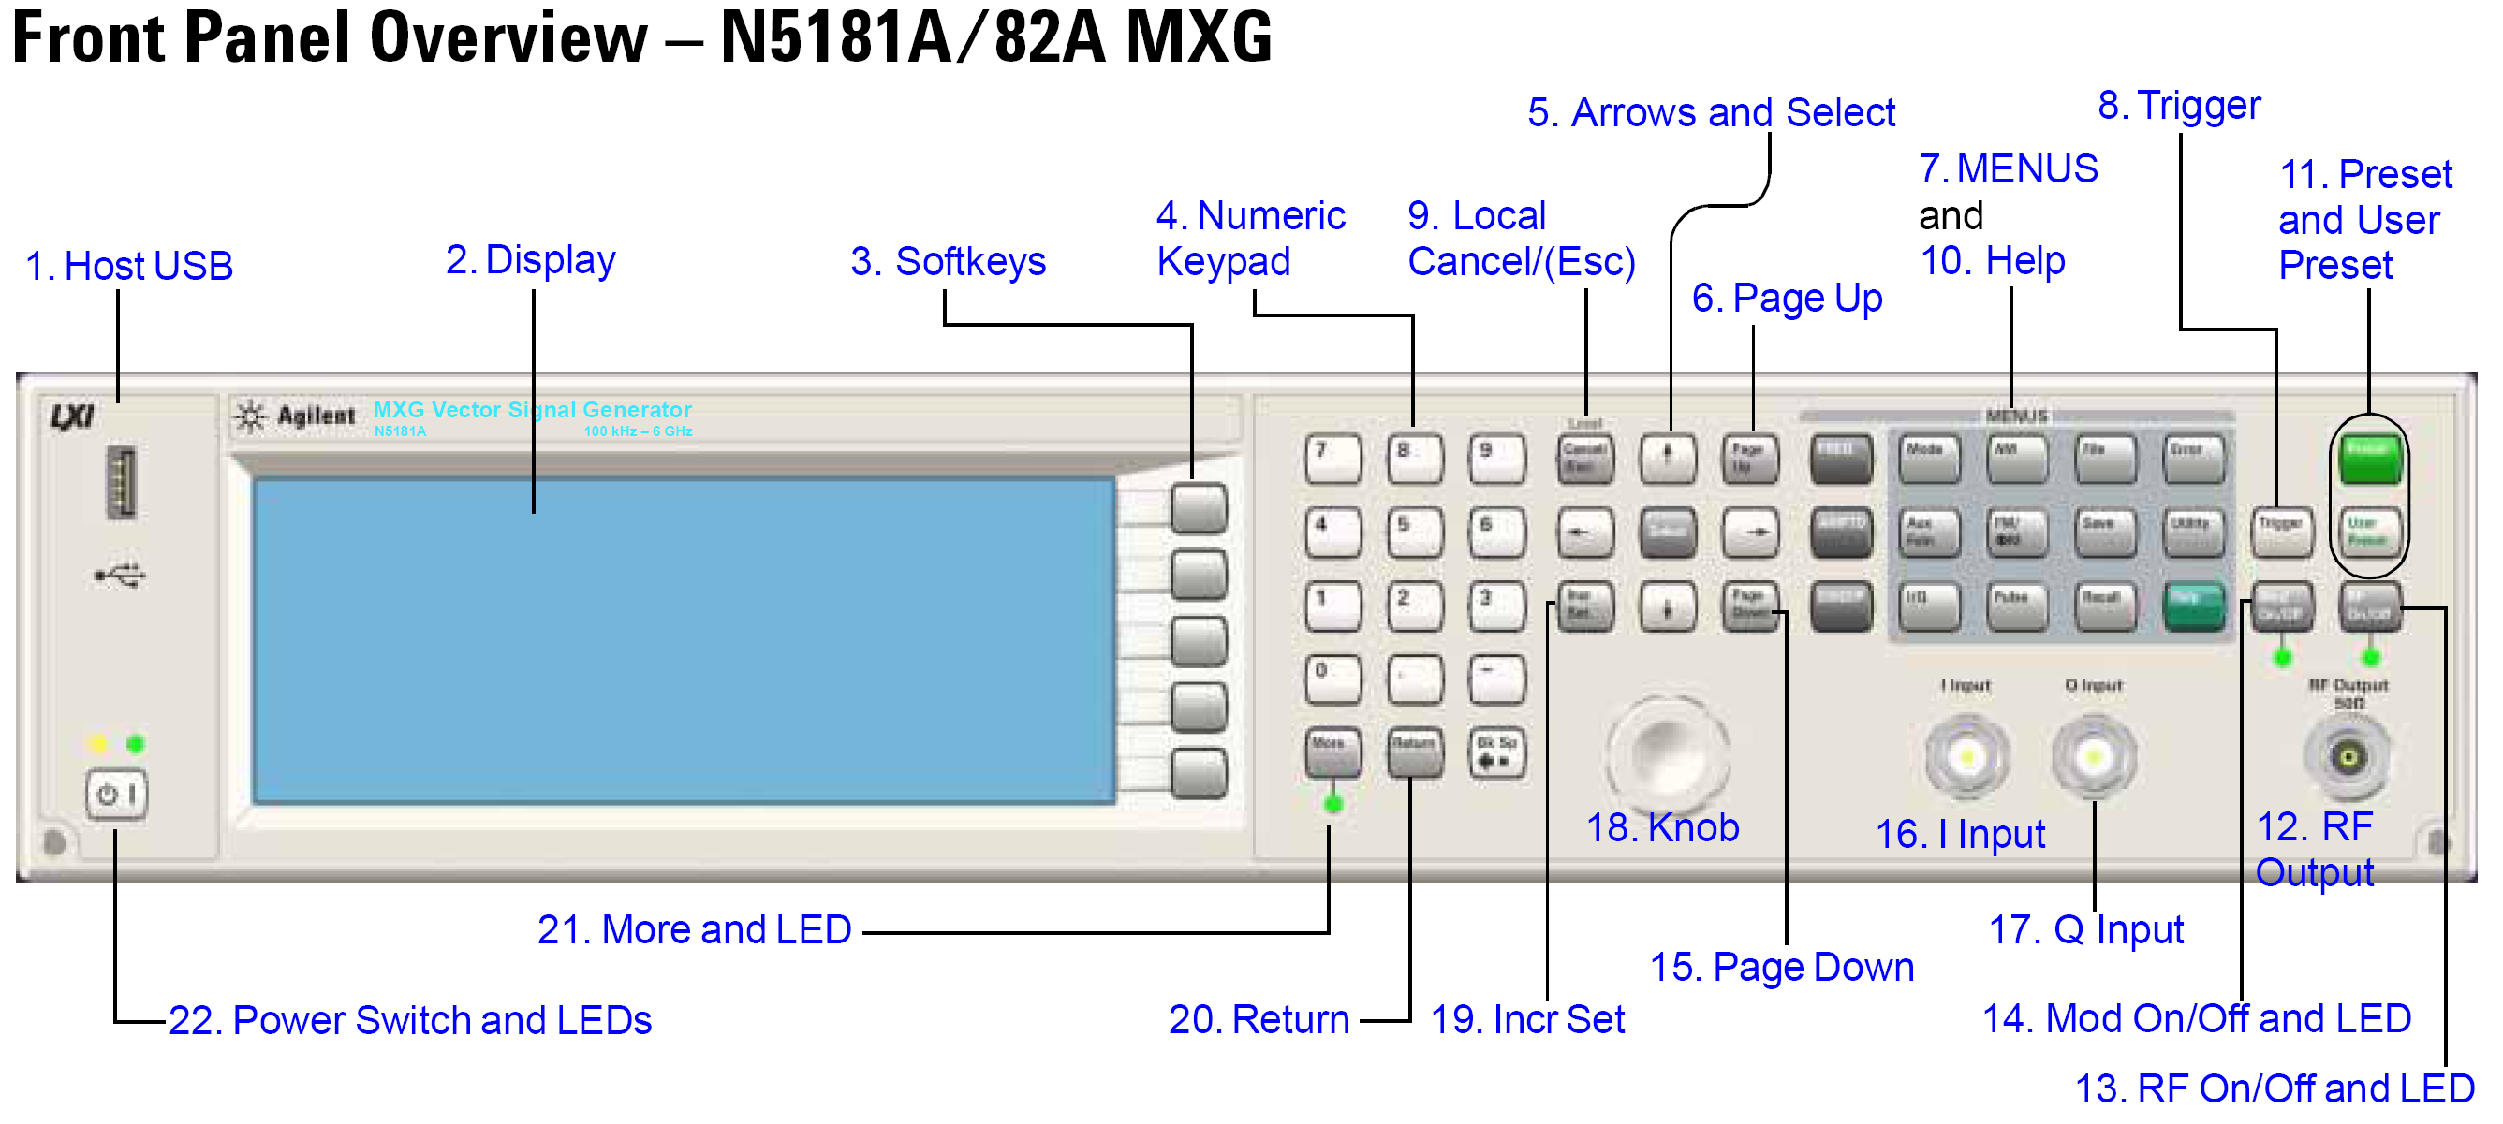
1
23. Modes
24. I/Q
2

3
4
5
Figure 47 Agilent N5181A/82A MXG Front Panel

Setting Common Mode Voltage

To apply 0.3 V common mode offset voltage to the IQ outputs:

- Press ‘IQ’ button (24)
- Press ‘IQ offsets (on/off)’ softkey (3. softkey 4)
- Press ‘external output adjustments’ softkey (3. softkey 4)
- Press ‘Common Mode I/Q offset’ softkey (3. softkey 2)
- type 0.3 on number pad (4), press ‘V’ softkey (3. softkey 1)
- 0.3 V should appear on the display next to the ‘Common Mode I/Q offset’ softkey
- Press return
    - Check text next to ‘I/Q Adjustments’ softkey (3. softkey 1) highlights ‘off/on’
    - If not press ‘I/Q Adjustments’ softkey (3. softkey 1), highlighted section should alternate between on and off when pressed.
    - press return
    - Check text next to ‘I/Q’ softkey (3. softkey 1) highlights ‘off/on’
    - If not press ‘I/Q’ softkey (3. softkey 1), highlighted section should alternate between on and off when pressed.

There should now be a 0.3 V common mode voltage on the differential IQ connections on the signal generator. This can be verified by measuring the DC level of each of the 4 differential I/Q lines with a multimeter.

Note: Very small DC offset levels in the transmit IQ path can result in LO breakthrough levels changing in the transmit chain. To eliminate or minimize this effect the following practices should be followed:

- The IQ cables should be of equal length.
- Once I/Q gain and phase calibration is completed, connections should not be modified.
- Cables and connections should not be moved once the I/Q gain and phase calibration is completed.

Enabling the Arbitrary Waveform Generator

The arbitrary waveform generator will run test vectors which are downloaded to it. These can be generated either with Agilent’s “Signal Studio” program or can be generated independently via “Matlab” or C.

Lime has a number of test vector files which are used for test and calibration of the LMS7002M as follows:

- DC.wfm – Differential DC tone for TX CW testing (clock 52 MHz).
- onetone1.wfm - single tone at 1 MHz offset for sideband suppression calibration/test (clock 52 MHz).
- twotone.wfm - two tone signal for linearity testing for MXG and LMS7002M use MXG IQ scaling factor of 30% (clock 52 MHz).
- wcdma31.wfm - TM2 WCDMA signal - use MXG IQ scaling factor of 30% (clock=15.36 MHz).
- EDGE3.wfm - GSM EDGE modulated test signal - (clock=13 MHz).

To download files to the signal generator follow the process described in section 1.40.3.

To apply the correct file

- Press ‘Mode’ button (23)
- Press ‘Dual Arb’ softkey (3. softkey 1)
- Press ‘Select waveform’ softkey (3. softkey 2)
- Use up/down arrows (5) or spin knob (18) to select the wanted waveform from list.
- Press ‘Select waveform’ softkey (3. softkey 1)
- The name of the selected waveform should now be present in the display window
- The soft key list should have moved up one level back to ‘Arb’
- Now change the Arb clock frequency
- Press ‘Arb setup’ softkey (3. softkey 3)
- Press ‘Arb sample clock’ softkey (3. softkey 1)
- Type in the required frequency on the number pad eg for 13 MHz type ‘13’ and press ‘MHz’ softkey (3. softkey 2)
- The sample clock frequency should now be displayed on the screen.
- Now scale the waveform data if necessary
- Go to the ‘Arb’ softkey menu
  - Either press the ‘return’ button from the ‘Arb setup’ menu or
  - Press the ‘Mode’ button then ‘Dual Arb softkey (3. softkey 1)
- Press the ‘More’ button (21)
- Press the ‘Waveform Utilities’ softkey (3. softkey 2)
- Use the up/down arrows (5) or spin wheel to highlight the wanted waveform from the list.
- Press the ‘scale waveform data’ softkey (3. softkey 2)
- Type in the required scaling factor e.g.25%, type ’25’ on number pad and press ‘%’ softkey (3. softkey 1).
Note – even if the text next to ‘scaling’ softkey already states 25% (for example) this does not mean it has been applied to the waveform, still follow the process.
- Press the ‘Apply to waveform’ softkey (3. softkey 4)
- The progress bar will show on screen, soft menu will return to level up (Arb utilities).
- Now return to the main ‘Arb’ Menu
  - Press the ‘return’ button twice or
  - Press the ‘Mode’ button then ‘Dual Arb softkey (3. softkey 1)
- Check that Arb in enabled
  - ‘Arb on/off’ softkey (3. softkey 1) the text should have on highlighted ‘Off / On’
  - If not, press the ‘Arb on/off’ softkey (3. softkey 1) to toggle between on and off.
- The modulation can be also be toggled on and off by the ‘Mod on/off’ button (just above the RF o/p connector). This must also be on – the green LED must be illuminated.
  - Press the ‘Mod on/off’ button to toggle the modulation on and off.
Note – The Mod on/off button turns the modulation on to the RF output and IQ output simultaneously. The RF does not need to be on for the IQ outputs to work

Downloading *.wfm Files to the Signal Generator

The following process should allow you to download files to the Agilent signal generator. The same process works for MXG and ESG.

This can be done via a network, however these instructions assume a direct connection between a PC running Windows 7 and the signal generator.

- Connect a cable between the PC network port and the signal generator LAN port.
- Check that the LEDs are illuminated on both ends to indicate that the HW is connected.
- Find the IP address of the Signal generator
  - Press the ‘Utility’ button
  - Press the ‘I/O config’ softkey (3. softkey 1)
  - Press the ‘LAN setup’ softkey (3. softkey 2)
  - The IP address should now be displayed on the screen
  - e.g.
IP Address : 192.168.2.92
Subnet Mask : 255.255.255.0
- Open a Command Prompt window on your PC
- Start
- In ‘Search programs and files’ window, type ‘cmd’
- The Command prompt window will pop-up
- Alternatively, it is located at C:\Windows\System32\
- Linux users can use a terminal session with the same commands.
- To check the connection to the signal generator attempt to ‘ping’ it
  - Type ‘ping 192.168.2.92’ (or use your sig gen IP address)
- A successful ping result should be returned as shown in .

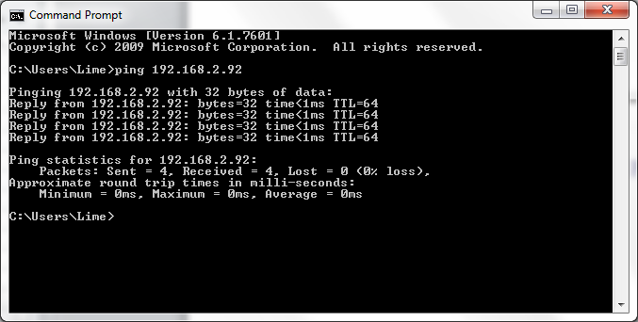

Figure 48 CMD window showing successful ping

To send wfm files to the signal generator the following procedure should be followed.
- Ensure that the wfm files are in a known directory e.g.
‘C:\Lime\Waveform’.
- In the ‘Command Prompt’ window set the directory to the one where the wfm files are located using the “CD” command.
- Use FTP to send files to the signal generator.
- Type ‘ftp 192.168.2.92’ as shown in Figure 49.

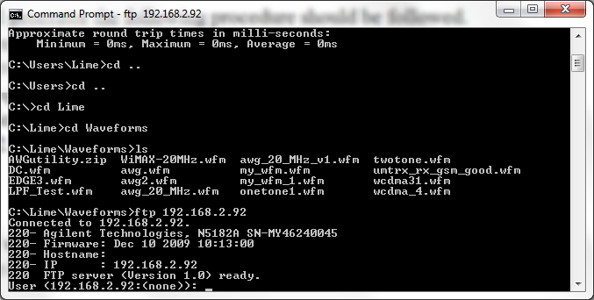

Figure 49 CMD window with ftp connection

- If you are correctly connected, then the above should be returned.
- Press ‘return’ twice (for user name and password – none needed)
- Type ‘cd bbg1’
- Type ‘cd waveform’
- Type ‘bin’
- Type ‘put wcdma31.wfm’
- The applied command copies files to the sig gen – repeat ‘put’ command for all files needed as shown in Figure 50.

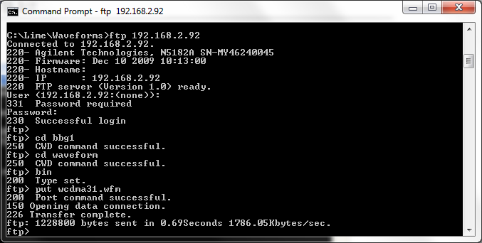

Figure 50 CMD window ftp file transfer

- To exit the ftp program type “bye”.
- To close the ‘Command Prompt’ window type exit.
- The wfm files should now be visible in the list of ARB files.

NOTICE OF DISCLAMER
The information disclosed to you hereunder (the “Materials”) is provided solely for the selection and use of Lime Microsystems products. To the maximum extent permitted by applicable law: (1) Materials are made available “AS IS” and with all faults, Lime Microsystems hereby DISCLAIMS ALL WARRANTIES AND CONDITIONS, EXPRESS, IMPLIED, OR STATUTORY, INCLUDING BUT NOT LIMITED TO WARRRANTIES OF MERCHANTABILITY, NON-INFRIGEMENT, OR FITNESS FOR ANY PARTICULAR PURPOSE; and (2) Lime Microsystems shall not be liable (whether in contract or tort, including negligence, or under any other theory of liability) for any loss or damage of any kind or nature related to, arising under, or in connection with, the Materials (including your use of the Materials), including for any direct, indirect, special, incidental, or consequential loss or damage (including loss of data, profits, goodwill, or any type of loss or damage suffered as a result of any action brought by a third party) even if such damage or loss was reasonably foreseeable or Lime Microsystems had been advised of the possibility of the same. Lime Microsystems assumes no obligation to correct any errors contained in the Materials, or to advise you of any corrections or update. You may not reproduce, modify, distribute, or publicly display the Materials without prior written consent. Certain products are subject to the terms and conditions of the Limited Warranties. Lime Microsystems products are not designed or intended to be fail-safe or for use in any application requiring fail-safe performance; you assume sole risk and liability for use of Lime Microsystems products in Critical Applications.

